**Seed Cards (0–20)**

**Master 62a**

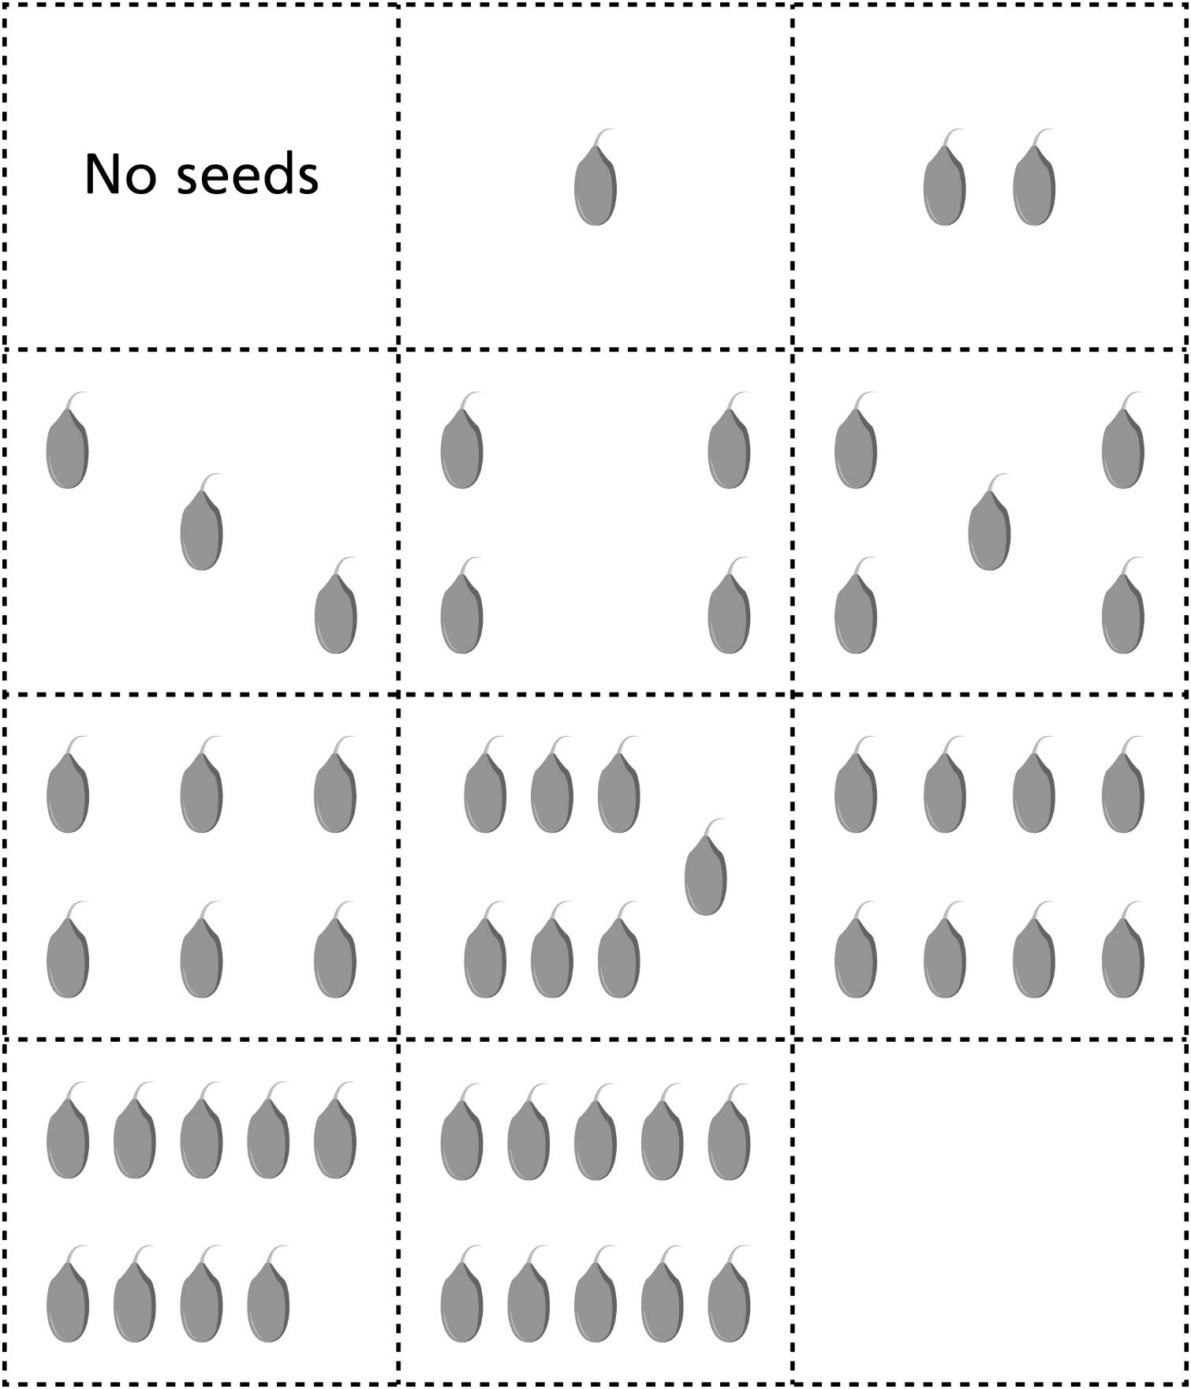

**Seed Cards (0–20)**

**Master 62b**

**b**

