Building, Naming, and Comparing Numbers Behaviours/Strategies
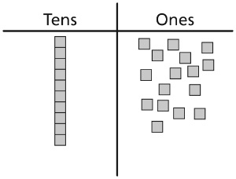  Student has more than 10 cubes but doesn’t use them to make a train. | Student represents a number with cubes but has difficulty relating the number of trains and cubes to tens and ones. | 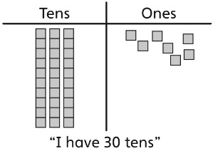  Student represents a number with cubes but confuses the number of tens with the number of cubes. | Student counts ones with ease to 9 but cannot bridge past 9 ones.  “twenty-nine, twenty-ten,  twenty-eleven”
Observations/Documentation
Student says, “2 tens and 3 ones,” but doesn’t know how to say the number. | Student says, “2 tens and 3 ones, twenty-three,” but doesn’t know how to write it using numerals. | Student decides which number is greater by comparing the total number of cubes used to show each number. | Student is able to build, name, and compare numbers using tens and ones.
Observations/Documentation

