Building Two-Digit Numbers Behaviours/Strategies
Student has difficulty recognizing and saying two-digit numbers.  “I don’t know that number.” | 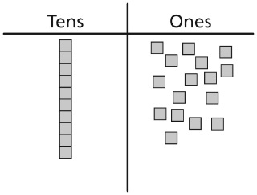  Student makes 1 train of ten and has more than 10 cubes in the Ones column. | 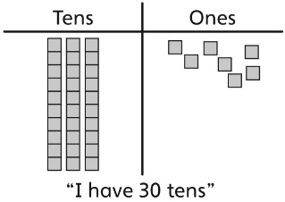  Student builds the number correctly using  tens and ones but confuses the number of tens with the number of cubes.
Observations/Documentation
Student builds the number correctly but is unable to relate the number of trains (tens) and single cubes (ones) to the digits of the number. | Student decides which number is greater by comparing the total number of cubes used to show each number. | Student builds the number correctly, understands the values of tens and ones, and successfully compares numbers.
Observations/Documentation

