Identifying and Partitioning Parts of a Whole Behaviours/Strategies
Student has difficulty identifying one-half in familiar situations.  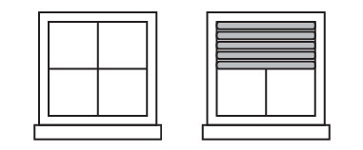  “I don’t know how much is covered.” | Student has difficulty partitioning a shape or object into two equal pieces.  “I folded it in half.” | Student identifies one-half of familiar shapes and objects, partitions shapes and objects into equal parts, and verifies that the two halves of the whole are the same size.  “The paper is folded in half, because both parts are the same size.”
Observations/Documentation

Making and Describing Equal Groups Behaviours/Strategies

Student struggles to partition an even set of up to 10 objects into 2 equal groups.  “I put the counters in equal groups.” | Student struggles to describe 1 of 2 equal groups as one-half.  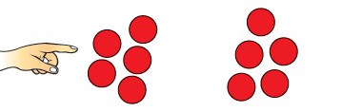  “5 counters.” | Student partitions even sets of up to 10 objects into 2 equal groups, describes each of the groups as one-half, and verifies that the 2 groups have the same number of objects.  “Each group is one-half of the whole group.”
Observations/Documentation

