Where’s the Other Half? Cards
Master 108a

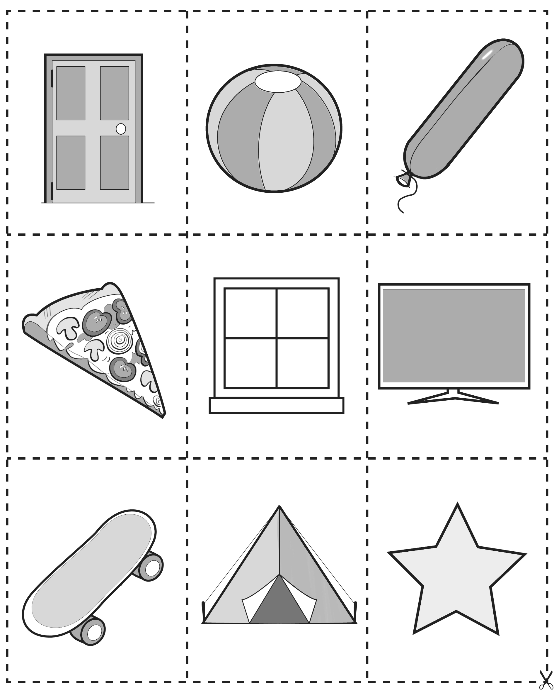
Where’s the Other Half? Cards
Master 108b

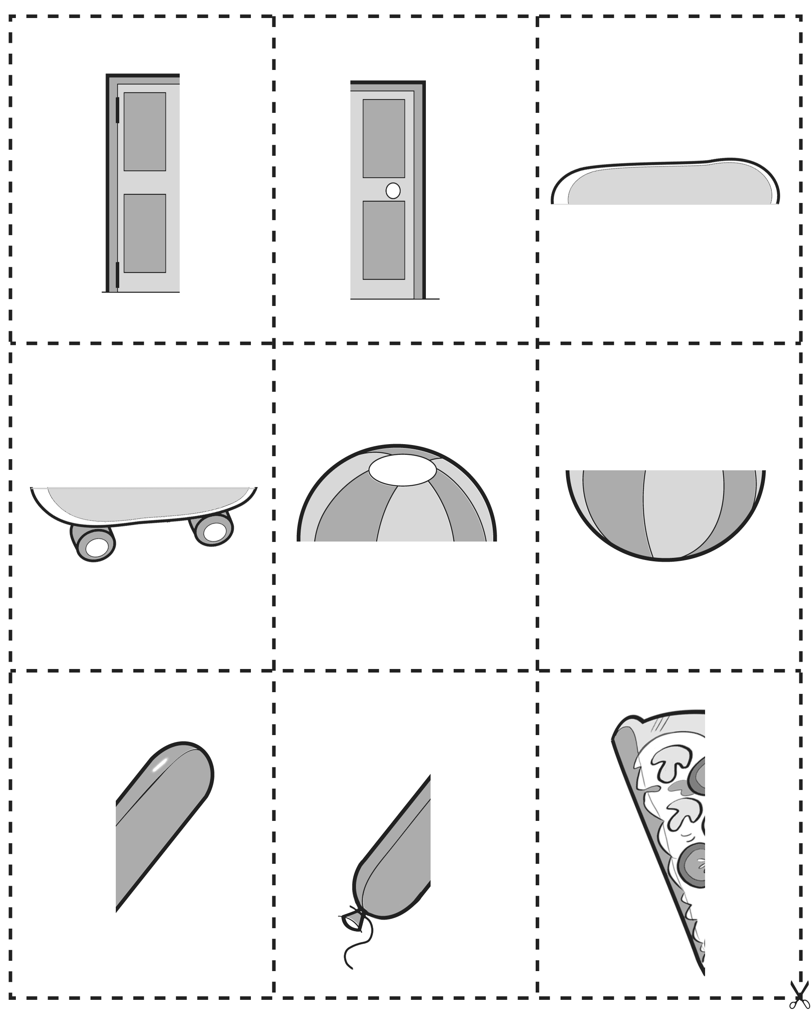

Where’s the Other Half? Cards
Master 108c

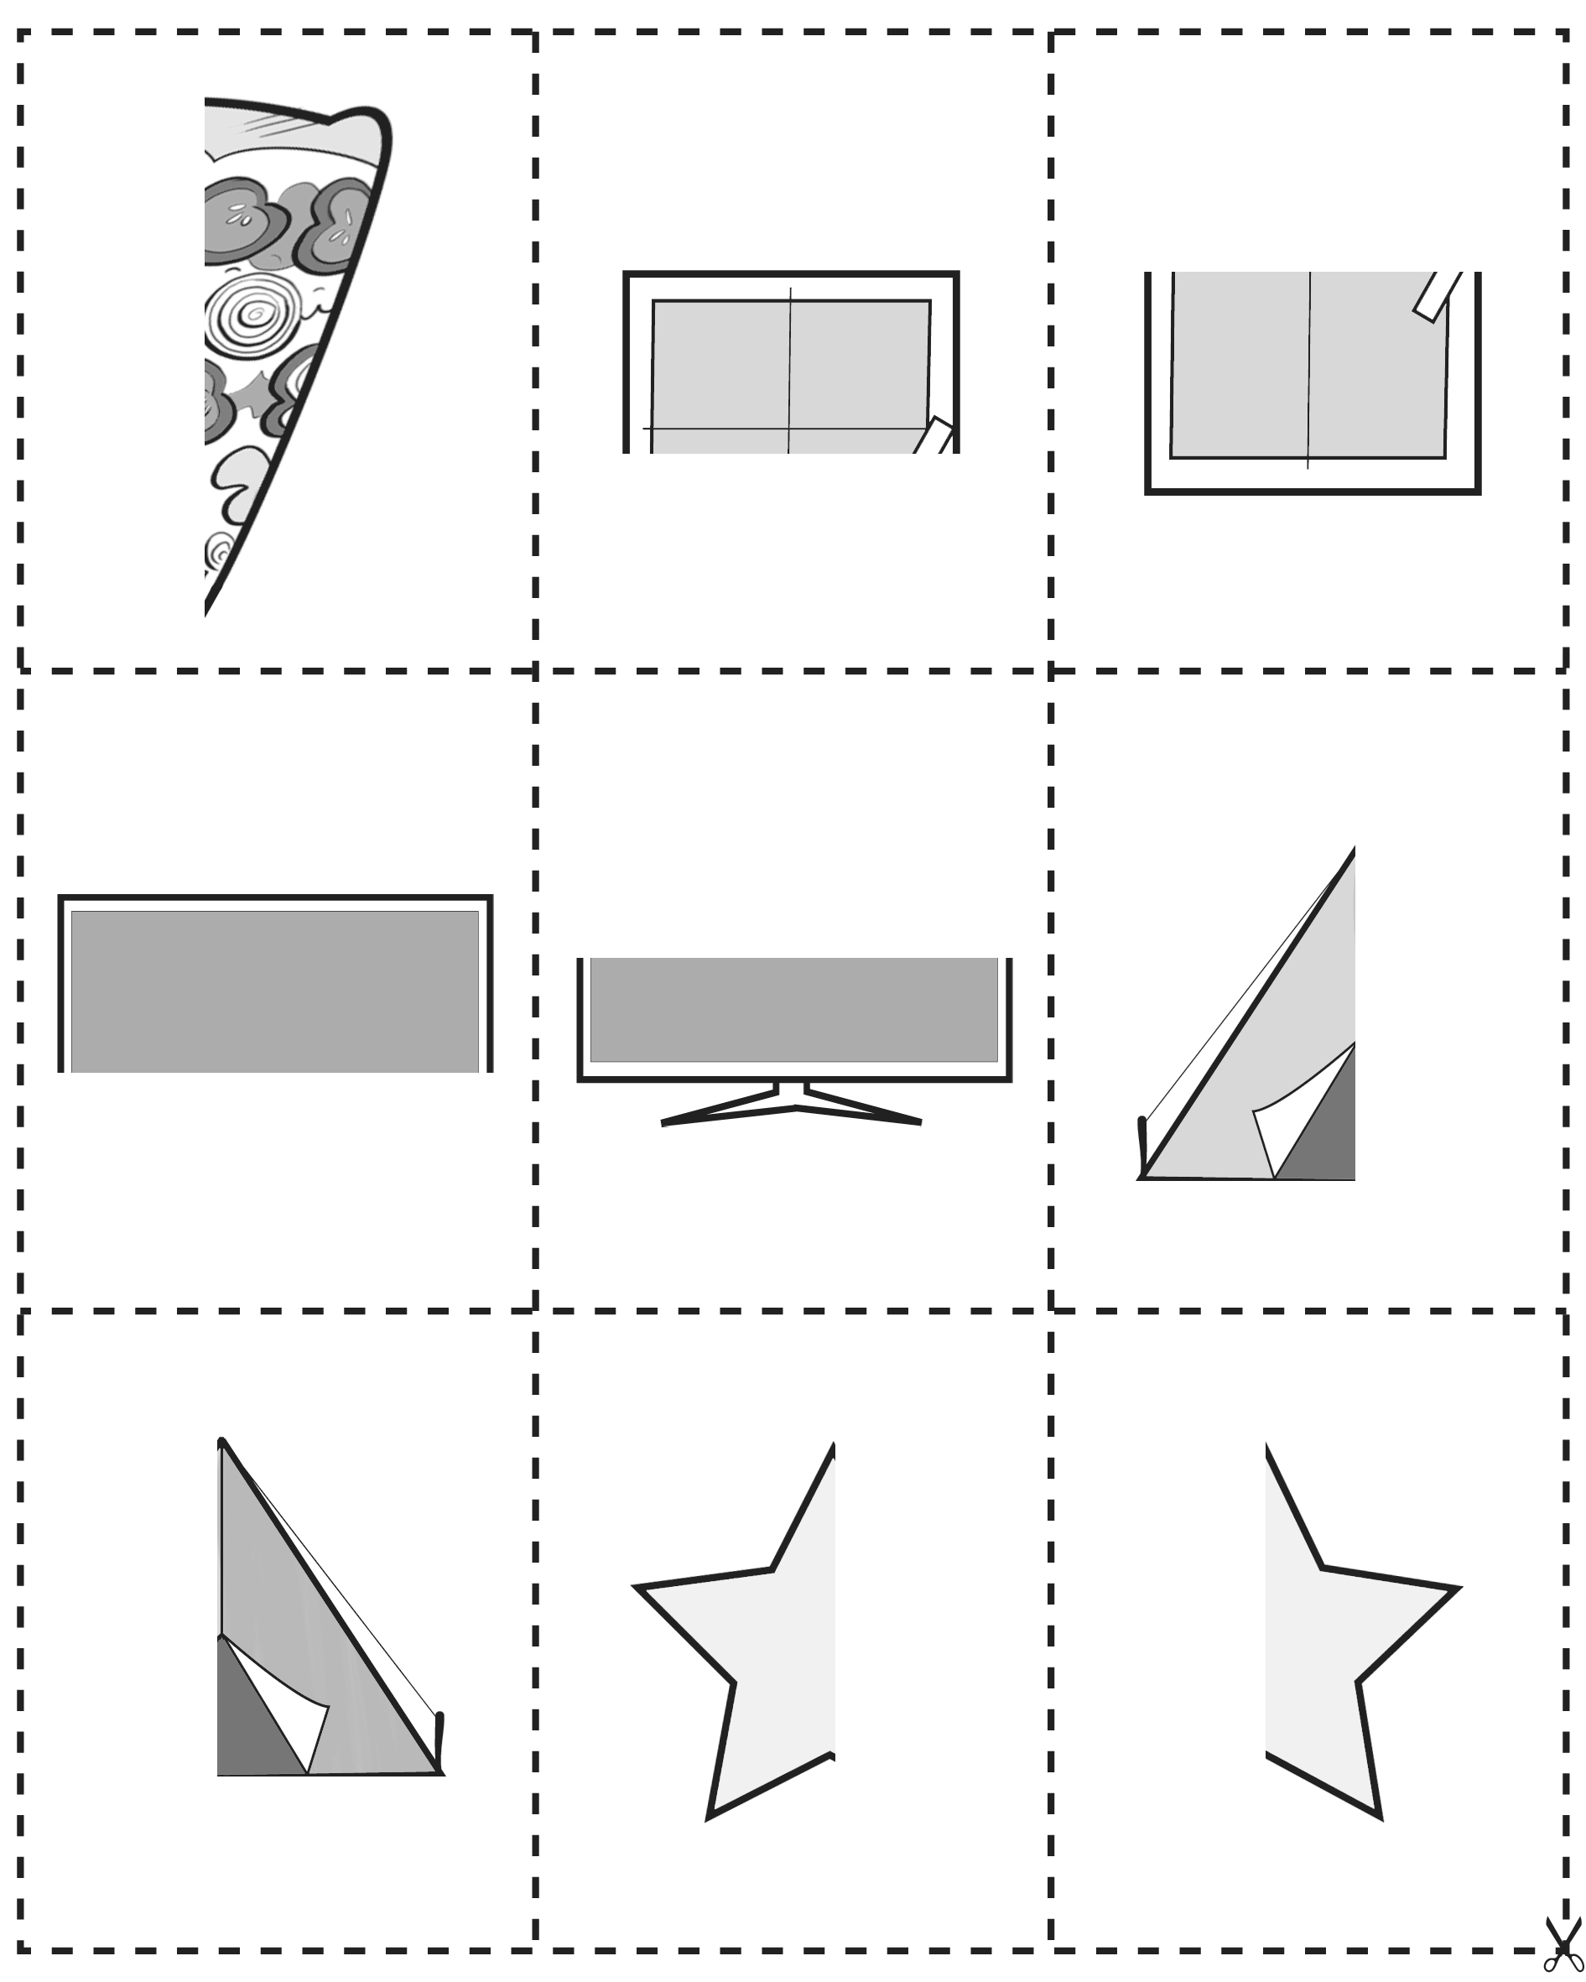

Where’s the Other Half? Cards (Combined Grade Extensions)
Master 108d

