**Shape Cutouts**

**Master 107a**

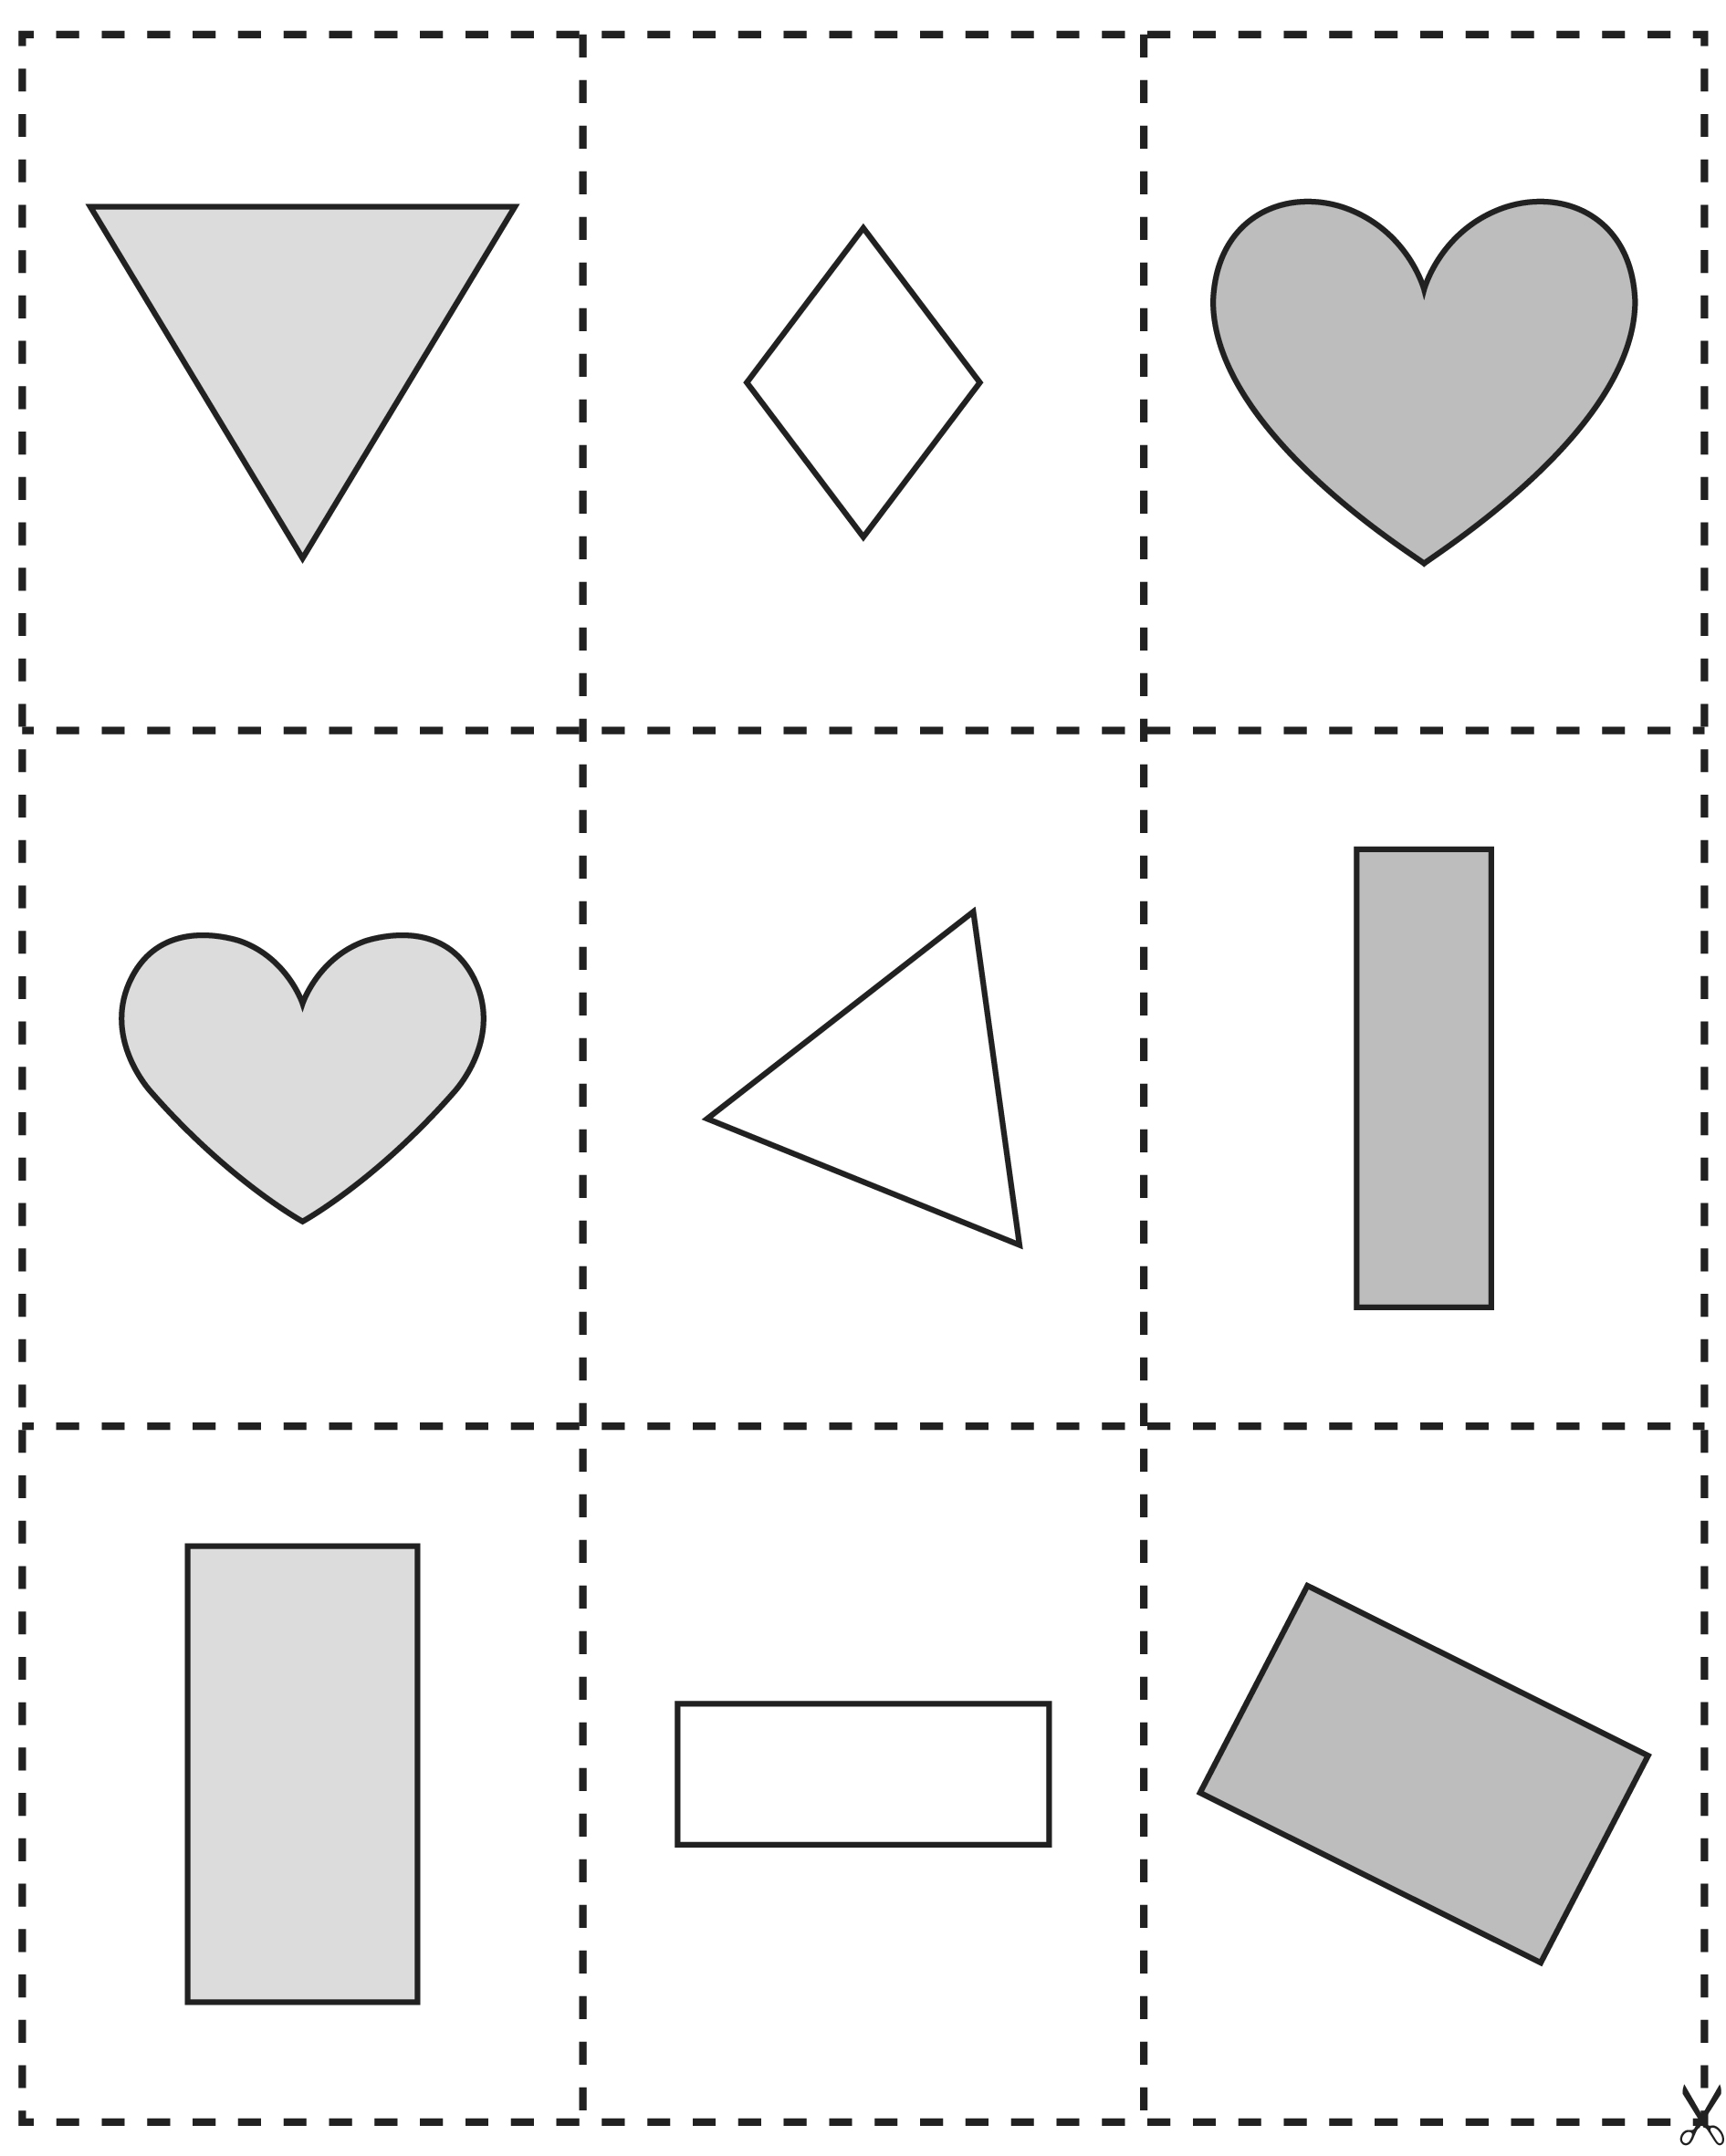

**Shape Cutouts**

**Master 107b**

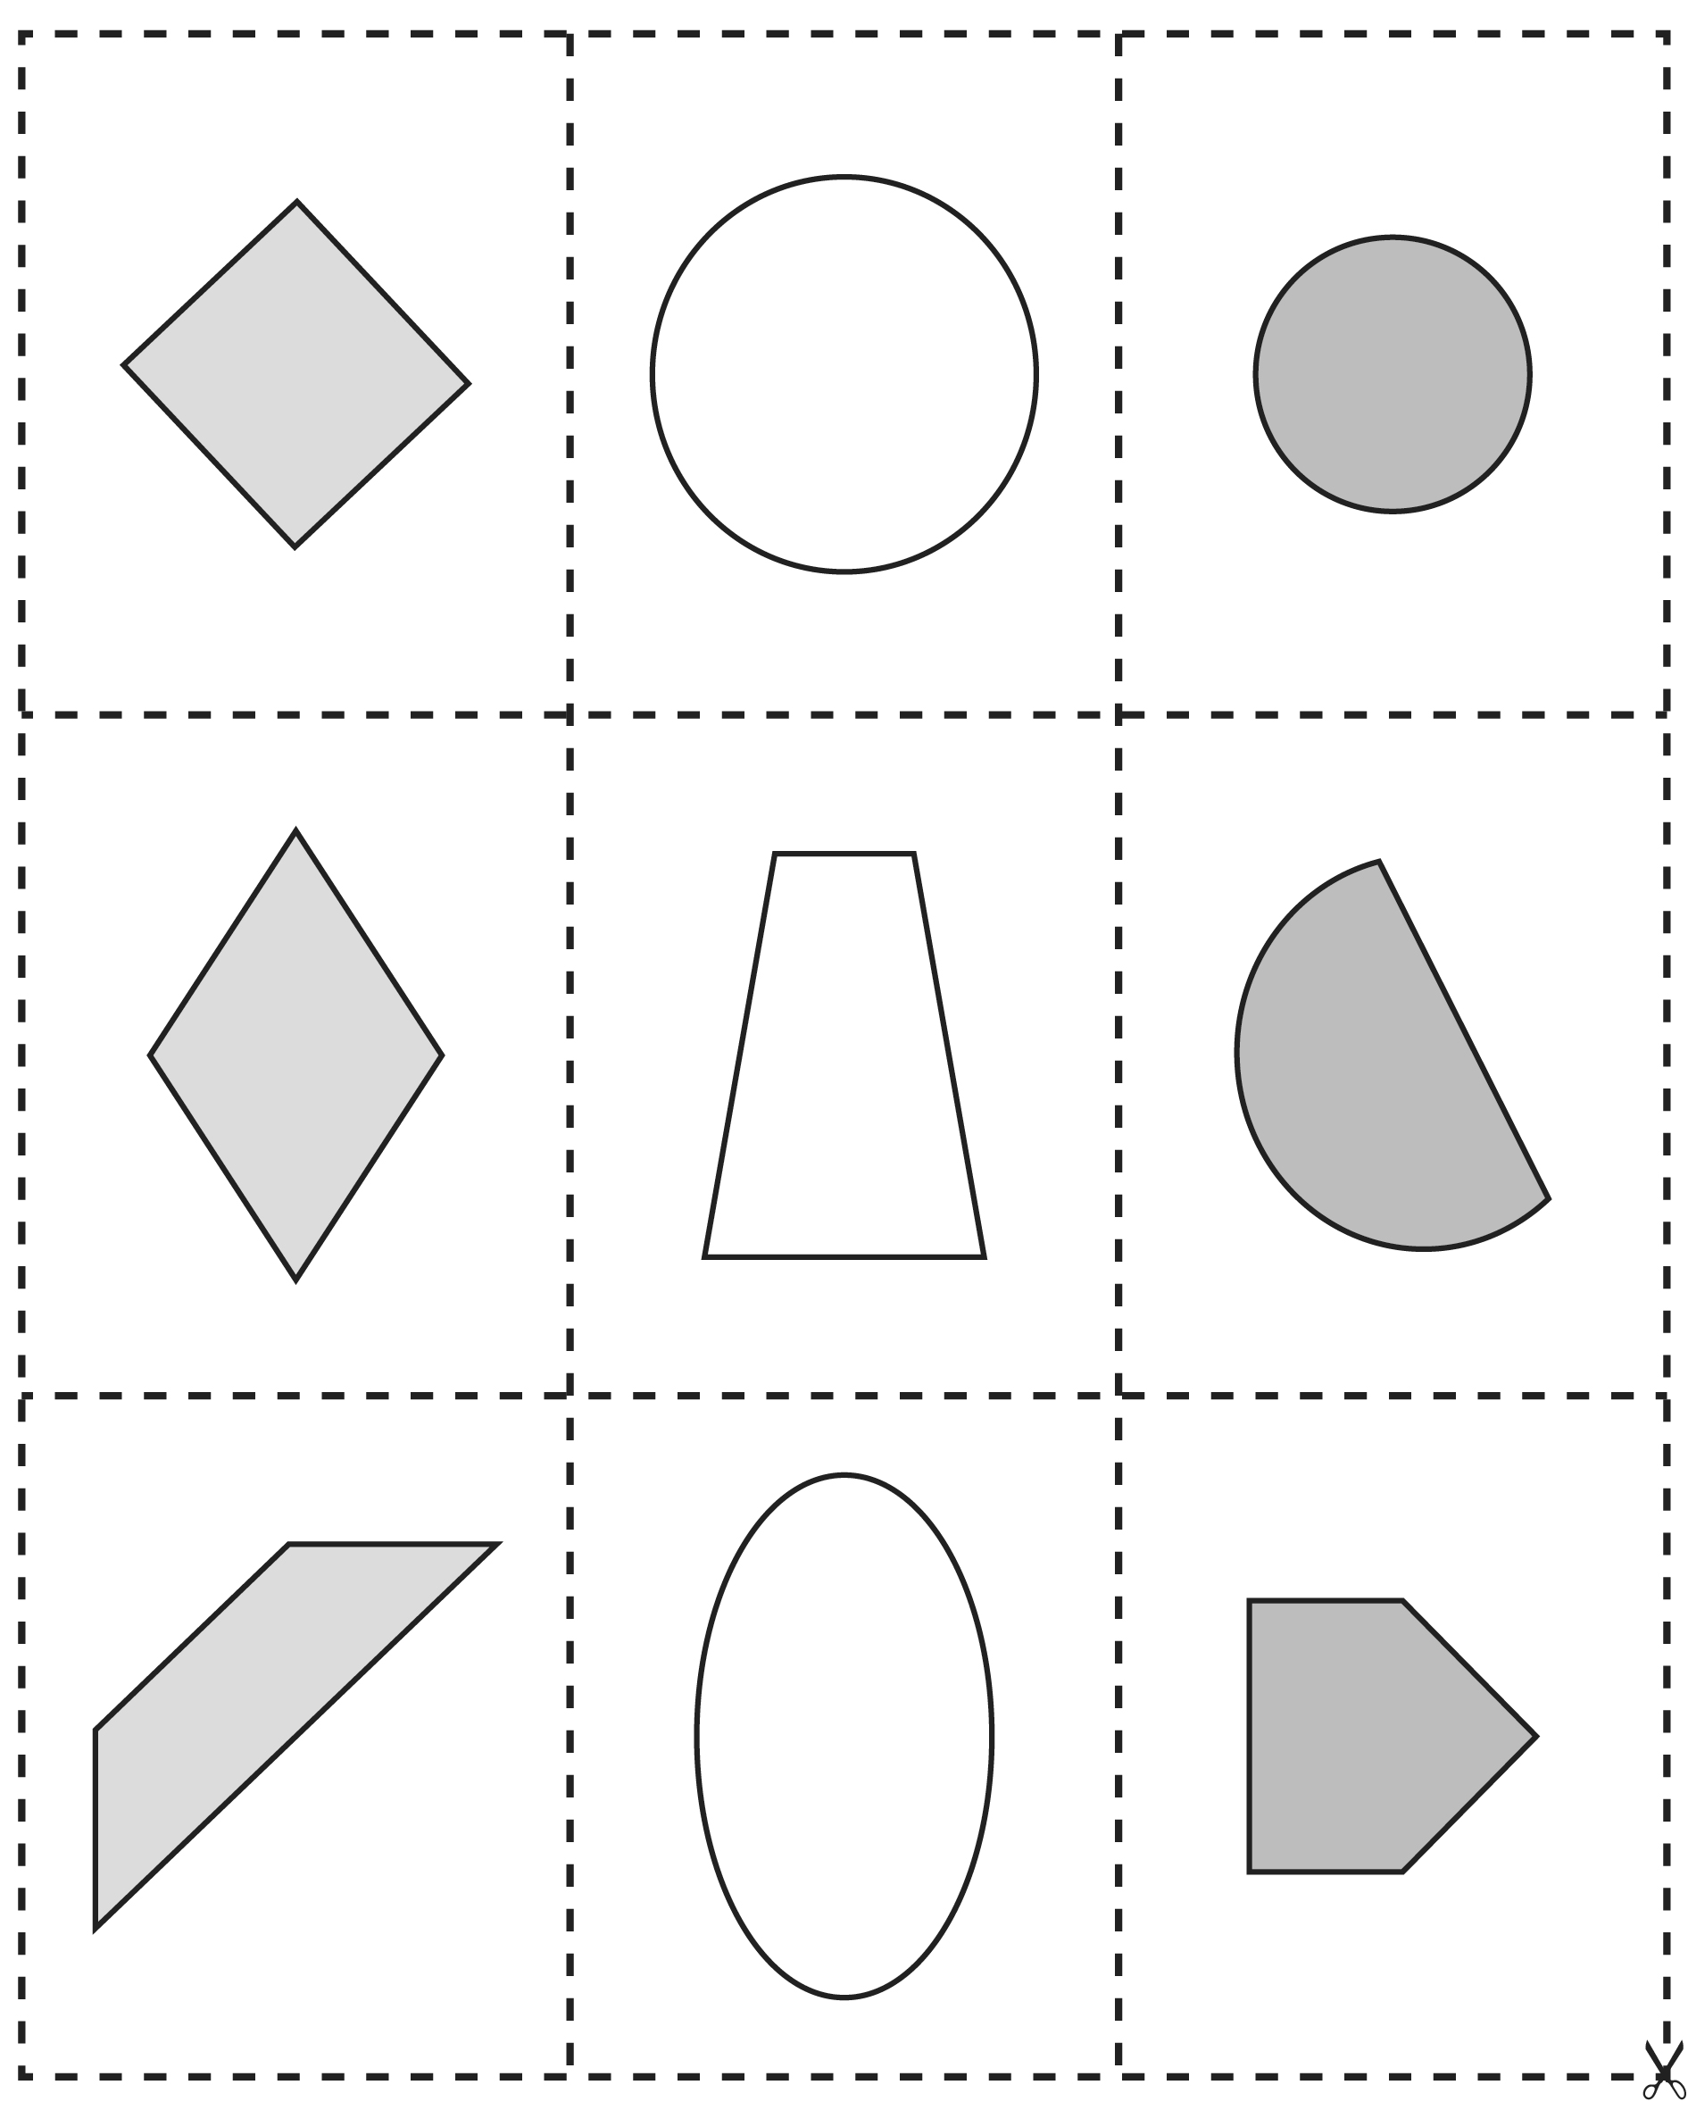

**Shape Cutouts**

**Master 107c**

