Making Equal Groups Behaviours/Strategies
Student makes towers of unequal numbers of cubes. | 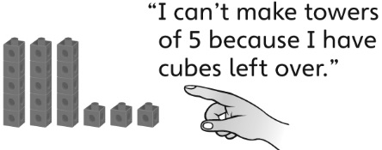  Student makes equal groups only when there are no leftovers. | Student groups the cubes into equal groups in more than one way.
Observations/Documentation
Counting Behaviours/Strategies
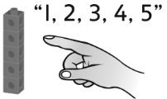  Student counts all the cubes by 1s when grouped in 2s, 5s, or 10s. | 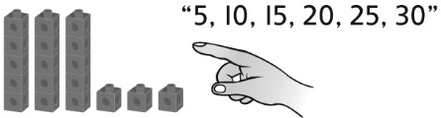  Student continues to skip-count to count the leftover cubes. | Student sees groups of cubes as one unit, fluently skip-counts by the unit, then counts on by 1s to find the total.  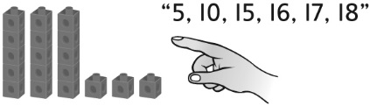
Observations/Documentation

