Representing and Counting Behaviours/Strategies
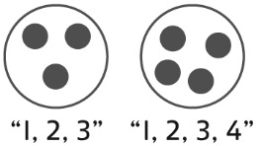  Student does not place all  10 counters in the pools. | Student selects numbers randomly, 5 and 5, then 3 and 7. | 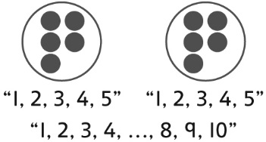  Student counts three times to confirm how many. | 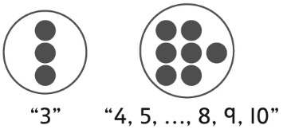  Student counts on to confirm how many.
Observations/Documentation
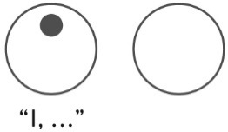  Student removes all counters and starts again to find a new way. | Student finds many possible ways, but does not consider 0 or 10 children in a pool. | 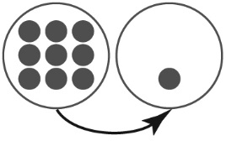  Student uses patterns to find all possible ways and models them with counters. | 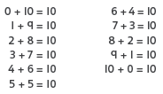  Student uses known number relationships to find all possible ways.
Observations/Documentation

