**Number Cards (1–10)**

**Master 29a**

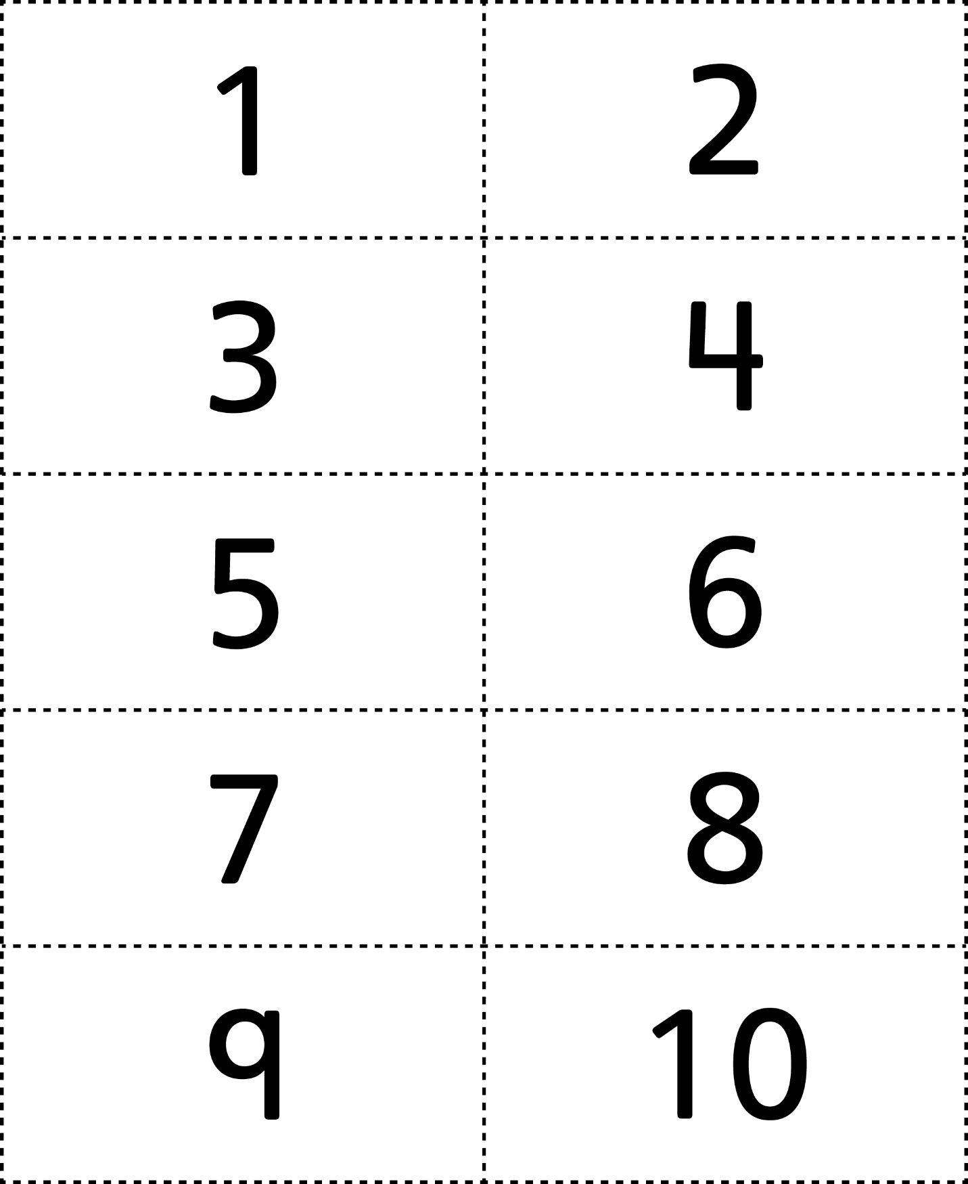



**Number Cards (11–20)**

**Master 29b**

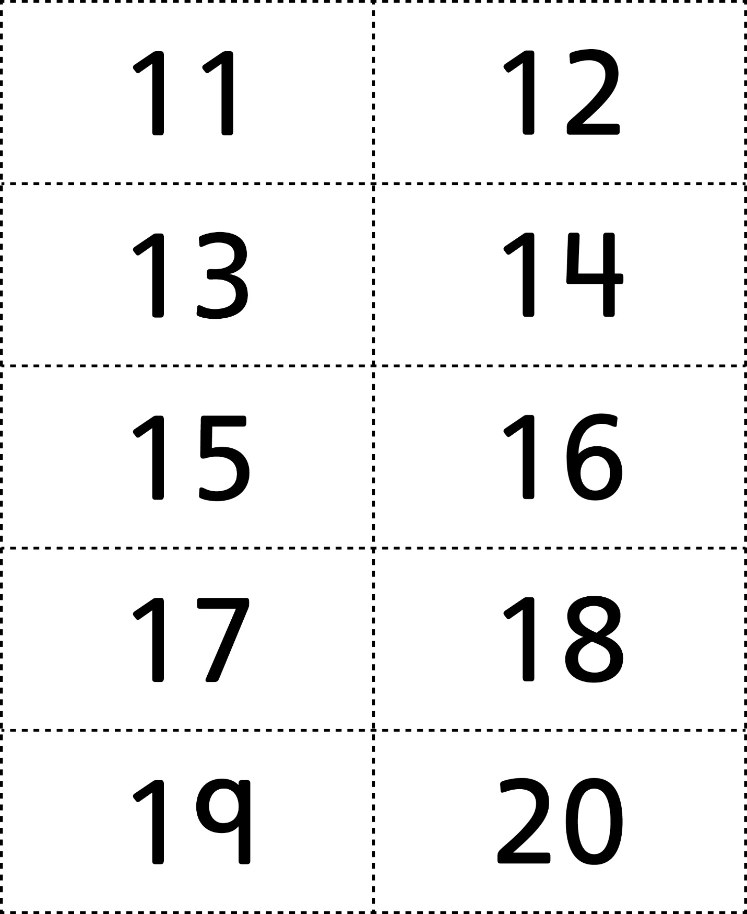



**Number Cards (21–30)**

**Master 29c**

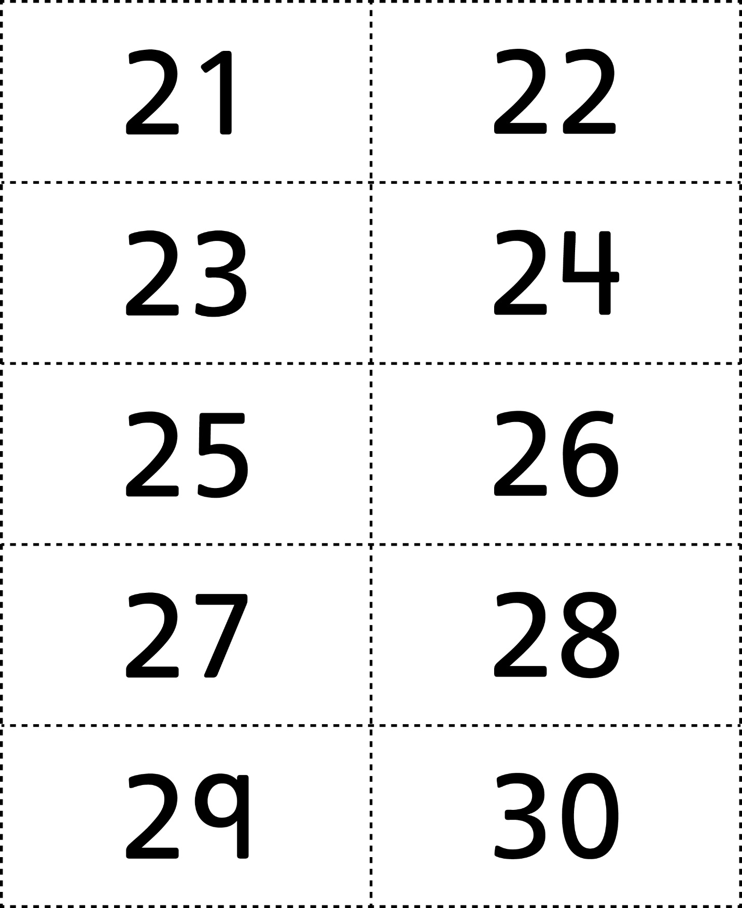



**Number Cards (31–40)**

**Master 29d**

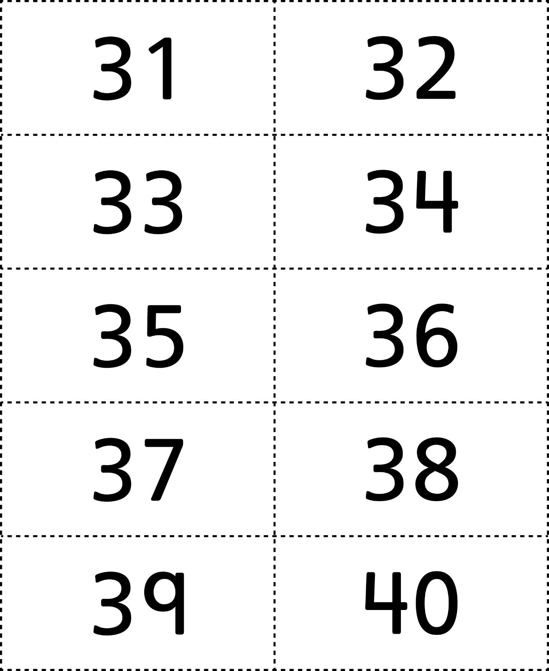



**Number Cards (41–50)**

**Master 29e**



**Number Cards (51–60)**

**Master 29f**

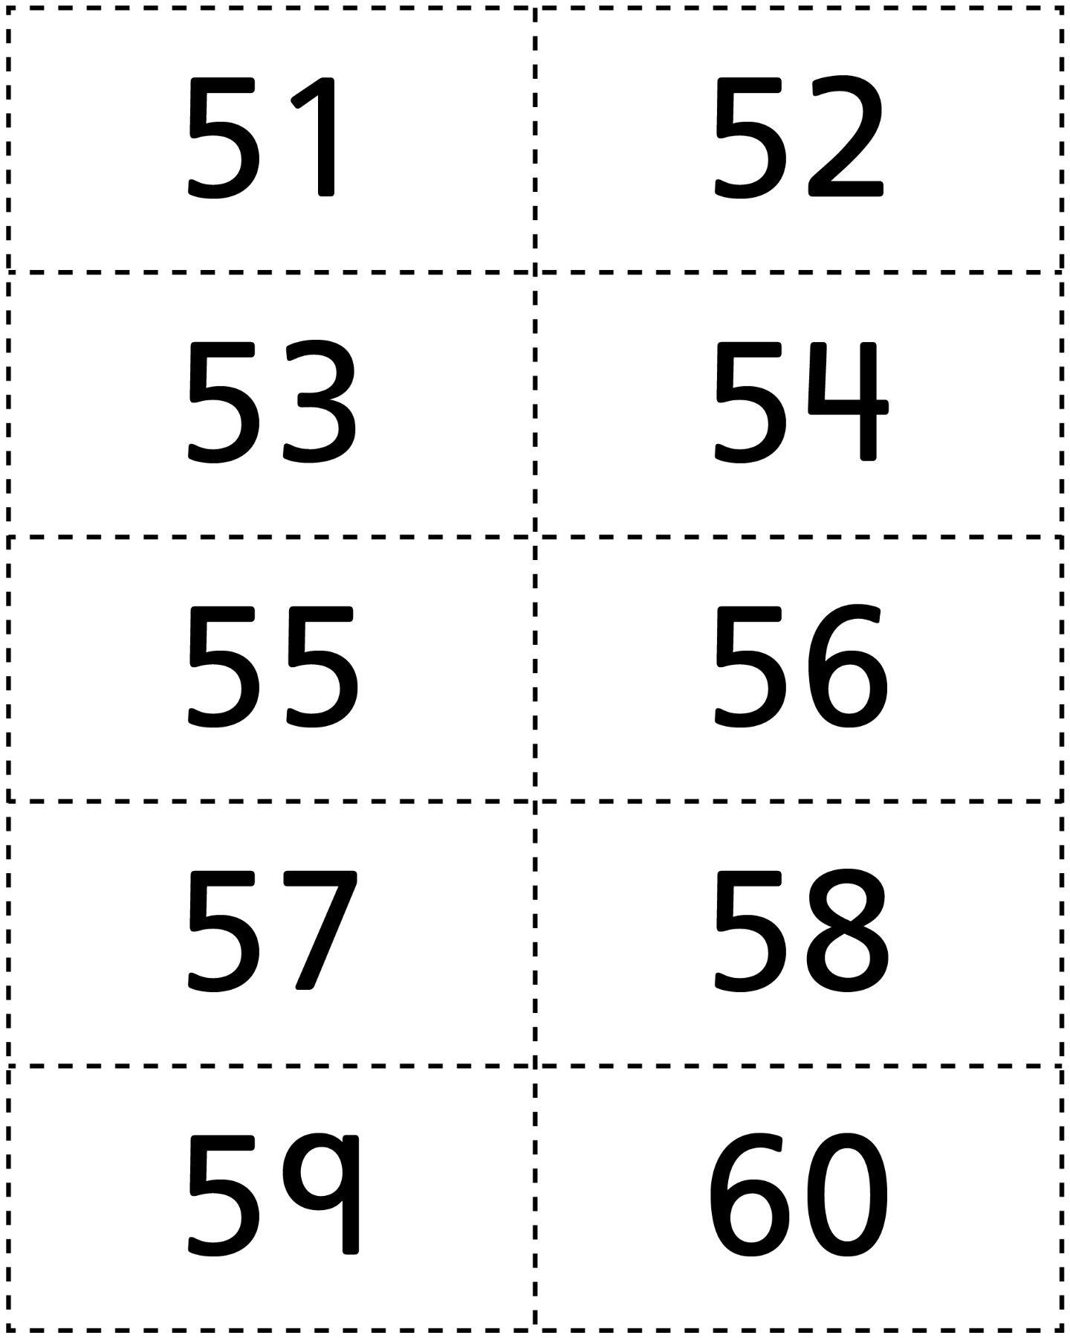



**Number Cards (61–70)**

**Master 29g**

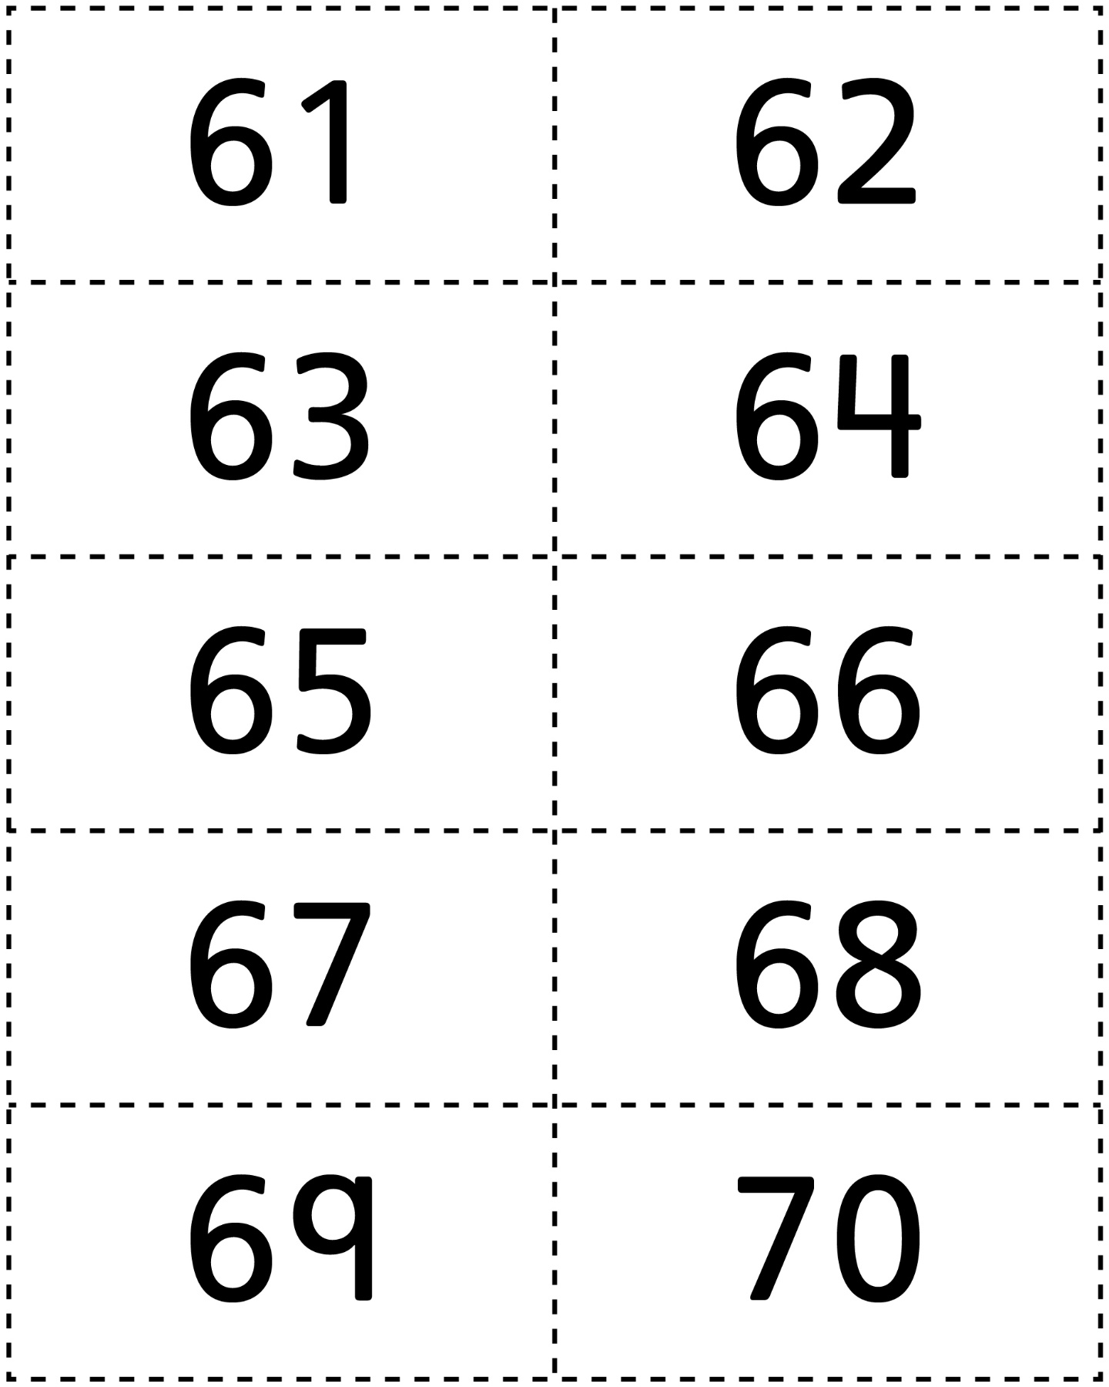

**Number Cards (71–80)**

**Master 29h**

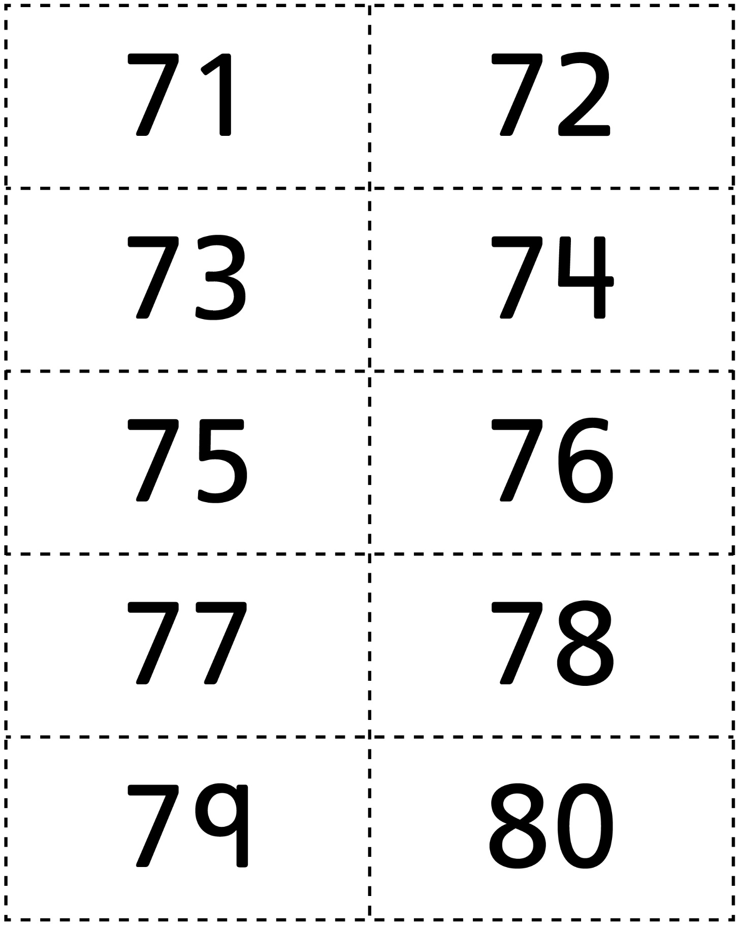

**Number Cards (81–90)**

**Master 29i**

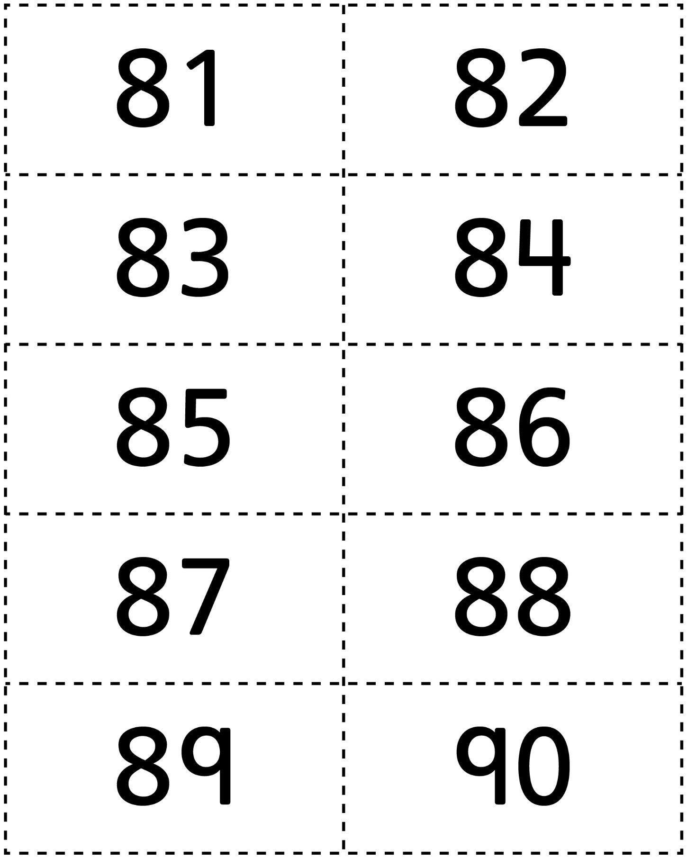



**Number Cards (91–100)**

**Master 29j**

