**Banana Cards**

**Master 28a**

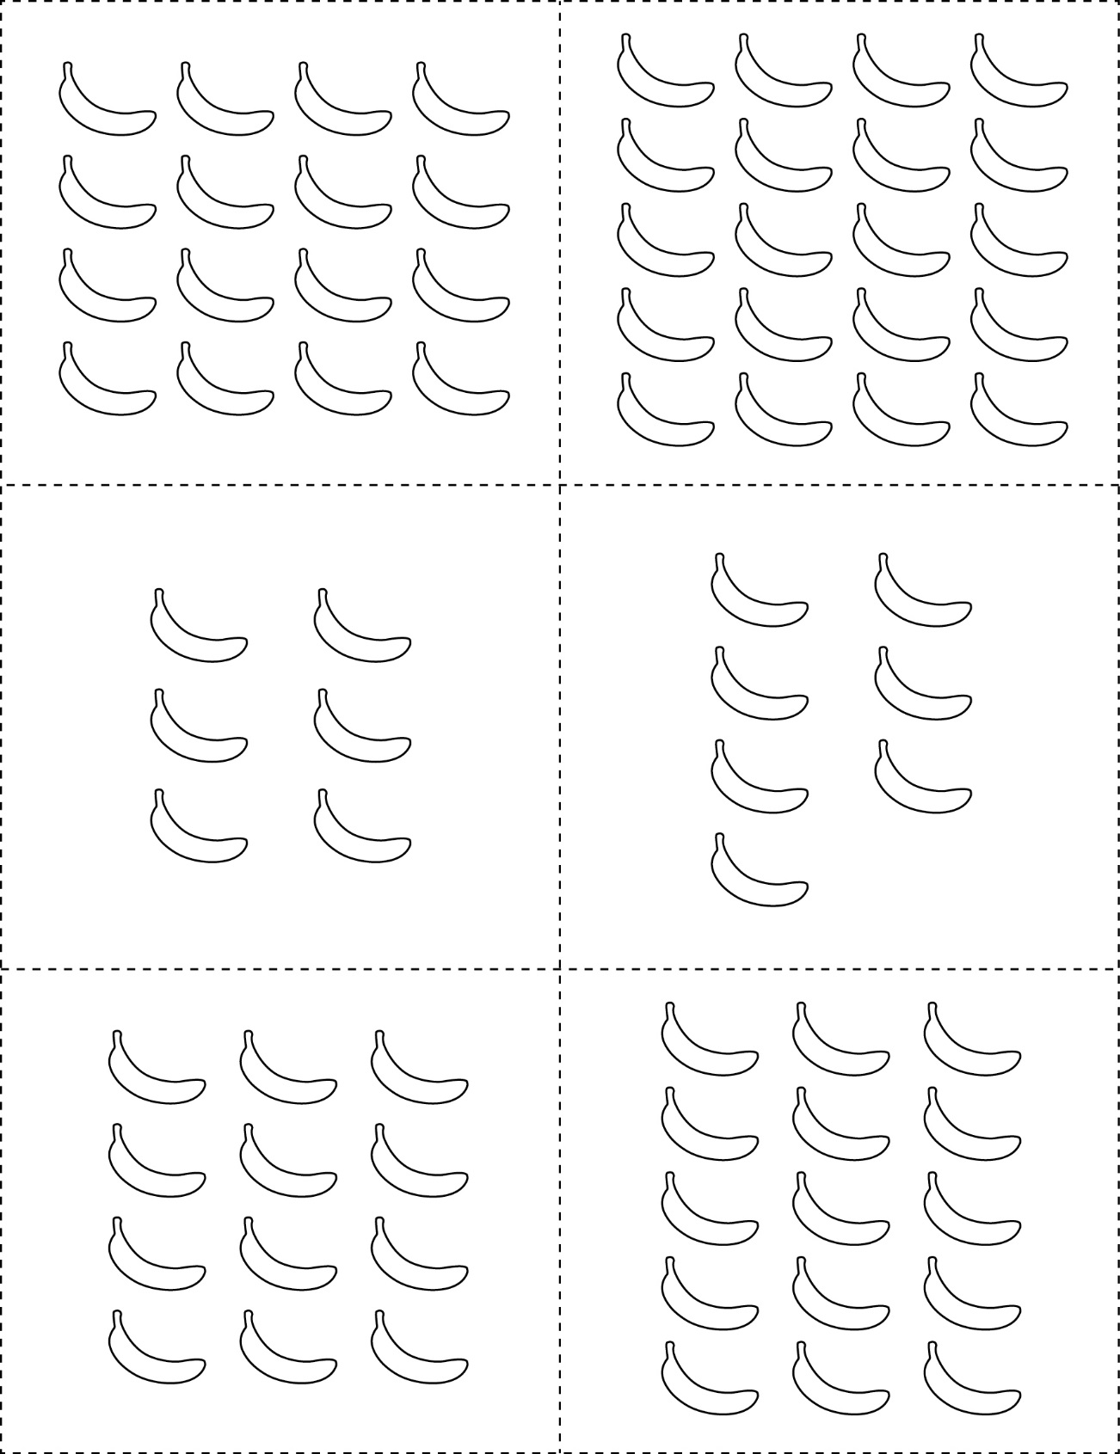



**Banana Cards**

**Master 28b**





**Banana Cards**

**Master 28c**

