Number Cards (0–9) (Accommodations)
Master 106a

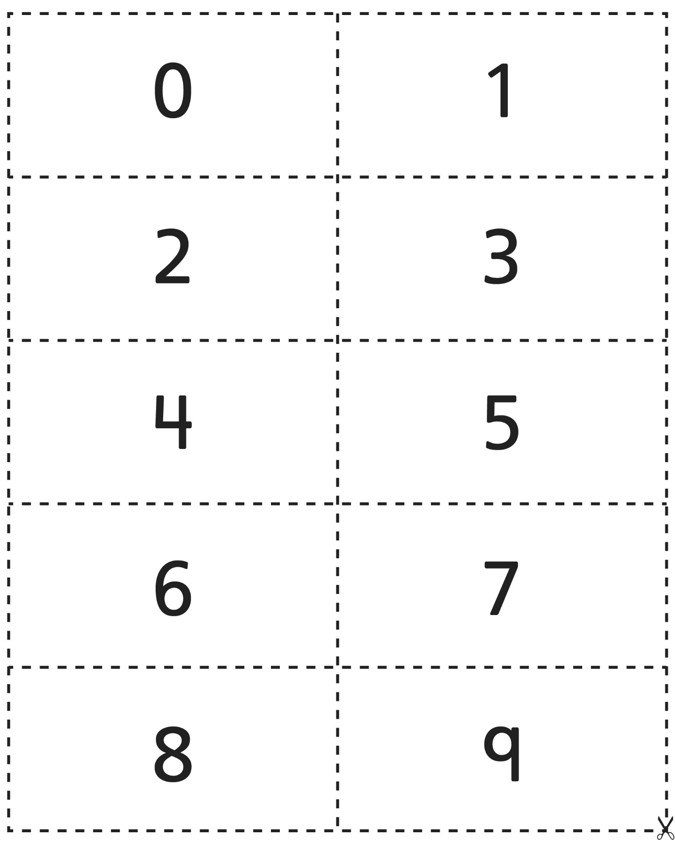
Number Cards (10–19) (Accommodations)
Master 106b

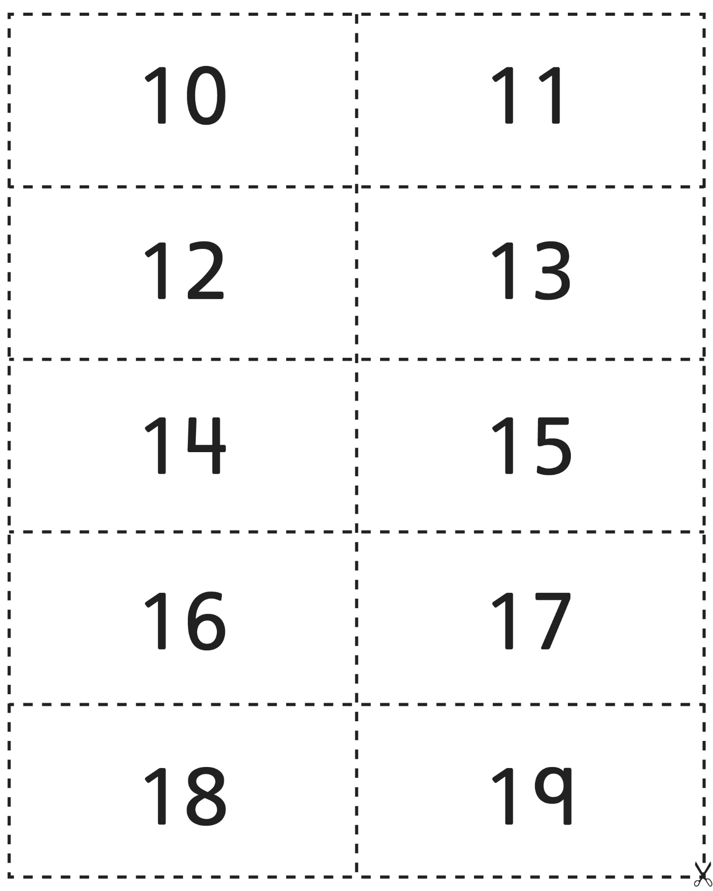
Number Cards (20) (Accommodations)
Master 106c

