Counting On and Counting Back Behaviours/Strategies
Student begins with start number, but omits numbers when saying number name sequences forward and backward.  “11, 12, 14, 16, 17, 18” | Student begins with start number, but mixes up the order when saying number name sequences forward and backward.  “11, 12, 14, 13, 15, 16” | 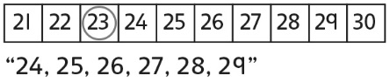  Student says the number name sequences forward and backward from a given number and relies on the hundred chart or class number line.
Observations/Documentation
Student says the number name sequences forward and backward from a given number, but struggles to bridge tens.  “Eight, nine, ten, ten-one, ten-two” | Student says the number name sequences forward and backward from a given number and successfully bridges tens, but does not recognize patterns in the number name sequence.  “I don’t see any patterns.” | Student says the number name sequences forward and backward from a given number and uses number patterns to bridge tens.
Observations/Documentation

