My Seasonal Activities
Master 28

Draw yourself doing something you like to do in each season.
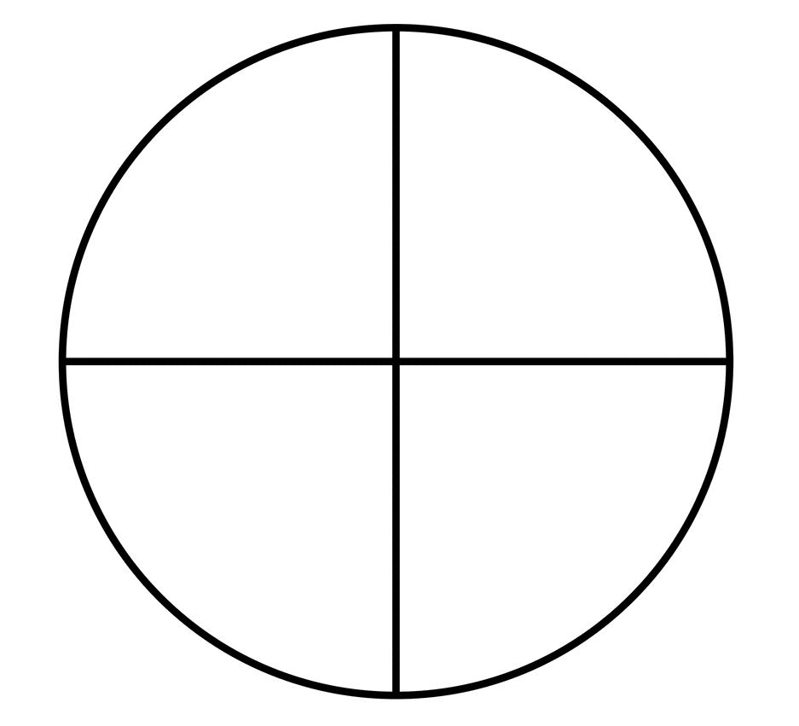

Fall
Winter
Summer
Spring

