Seasonal Inuit Practices
Master 27a

Hunting in Spring

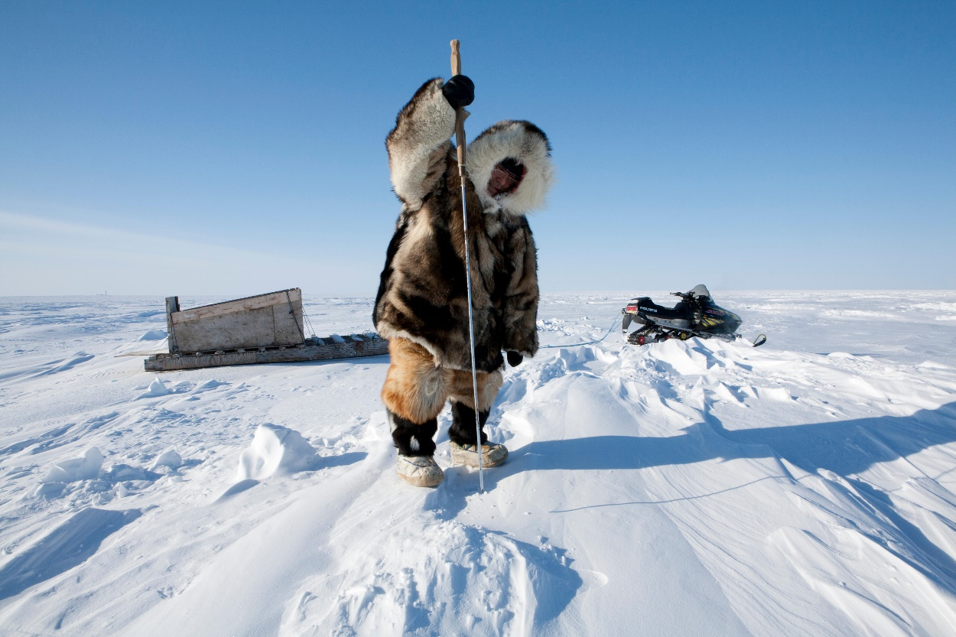

Dogsledding in Spring

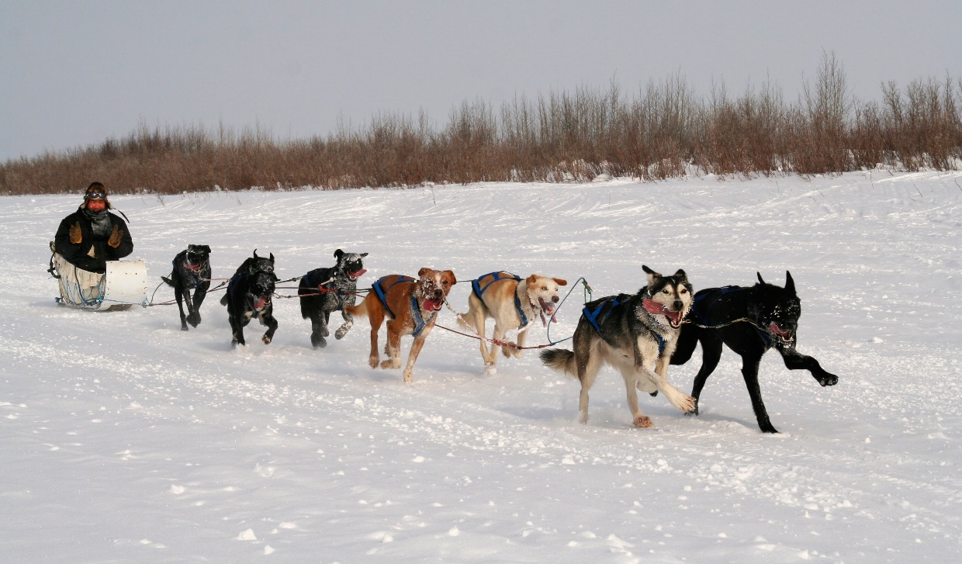

Seasonal Inuit Practices
Master 27b

Fishing in Spring

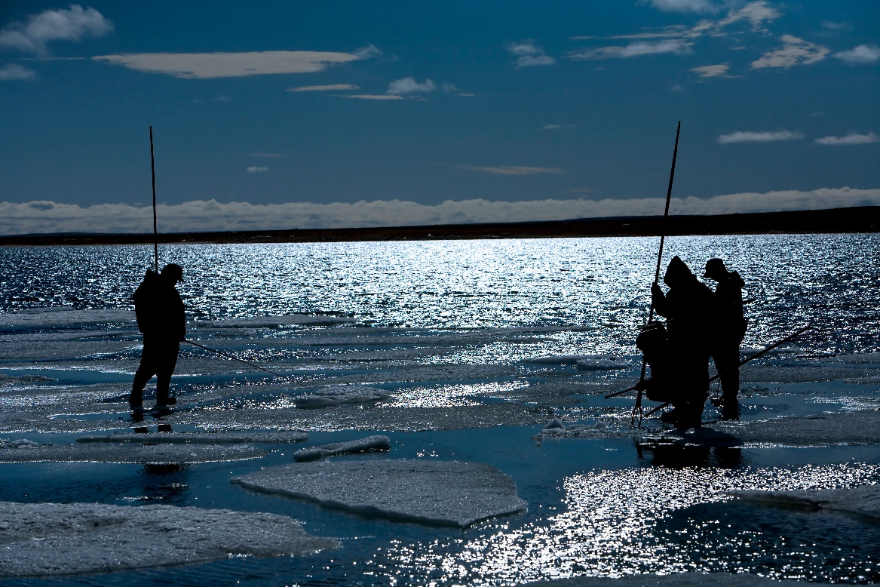

Kayaking in Summer

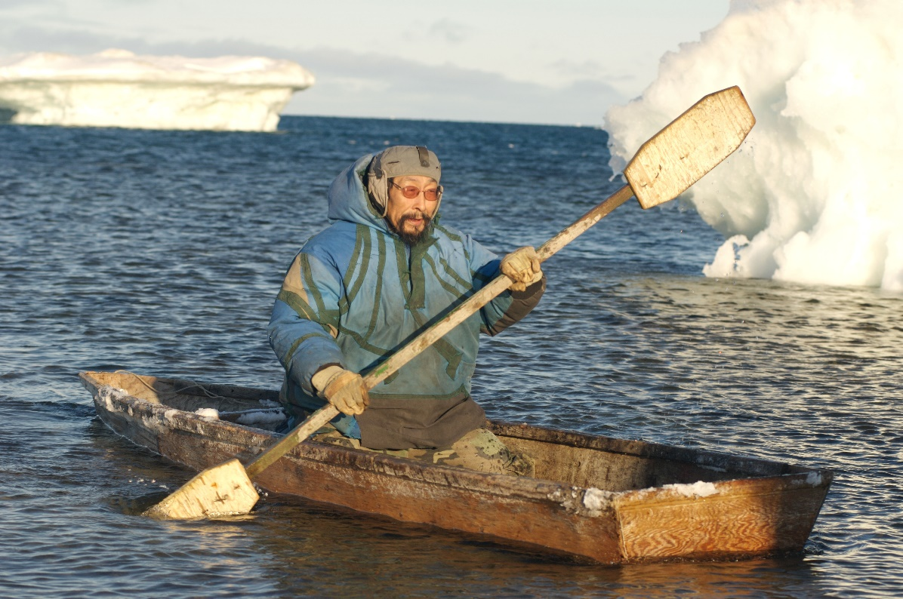
Seasonal Inuit Practices
Master 27c

Picking Berries in Fall

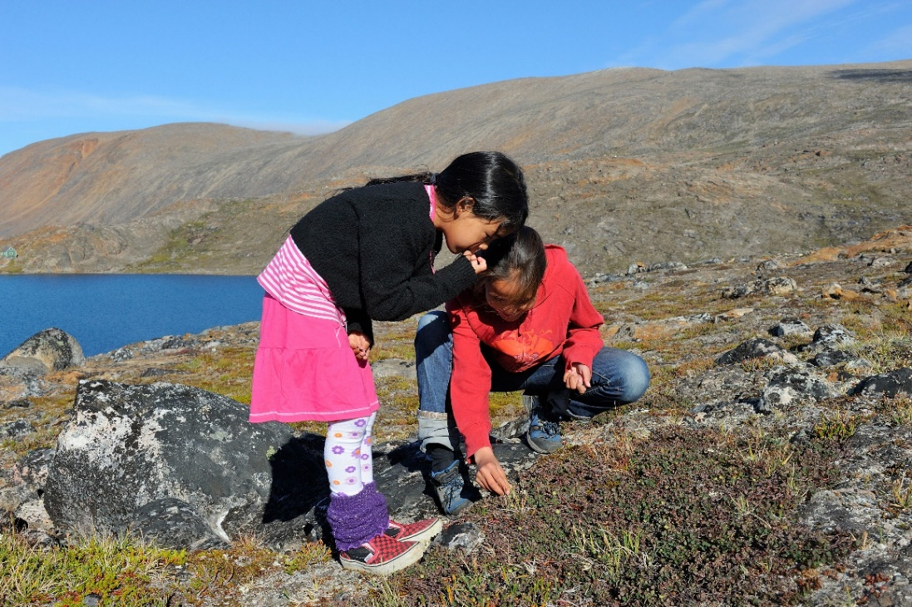

Sewing in Winter

