Identifying Cycles in the Calendar Behaviours/Strategies
Student does not know the days of the week and/or months of the year. | Student mixes up the order of the days of the week and/or months of the year.  “Sunday, Monday, Tuesday, Thursday, Wednesday, Friday, Saturday, …” | Student has difficulty identifying cycles in the days of the week and/or months of the year.  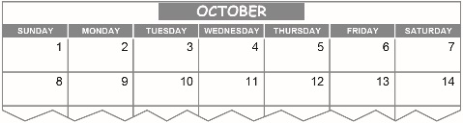  “The days are here.  I’m not sure about the cycles.” | Student identifies cycles in days of the week and months of the year with ease.  “The days of the week repeat in the same order over and over. So do the months of the year.”
Observations/Documentation

