**Ordinal Number Cards**

**Master 20a**

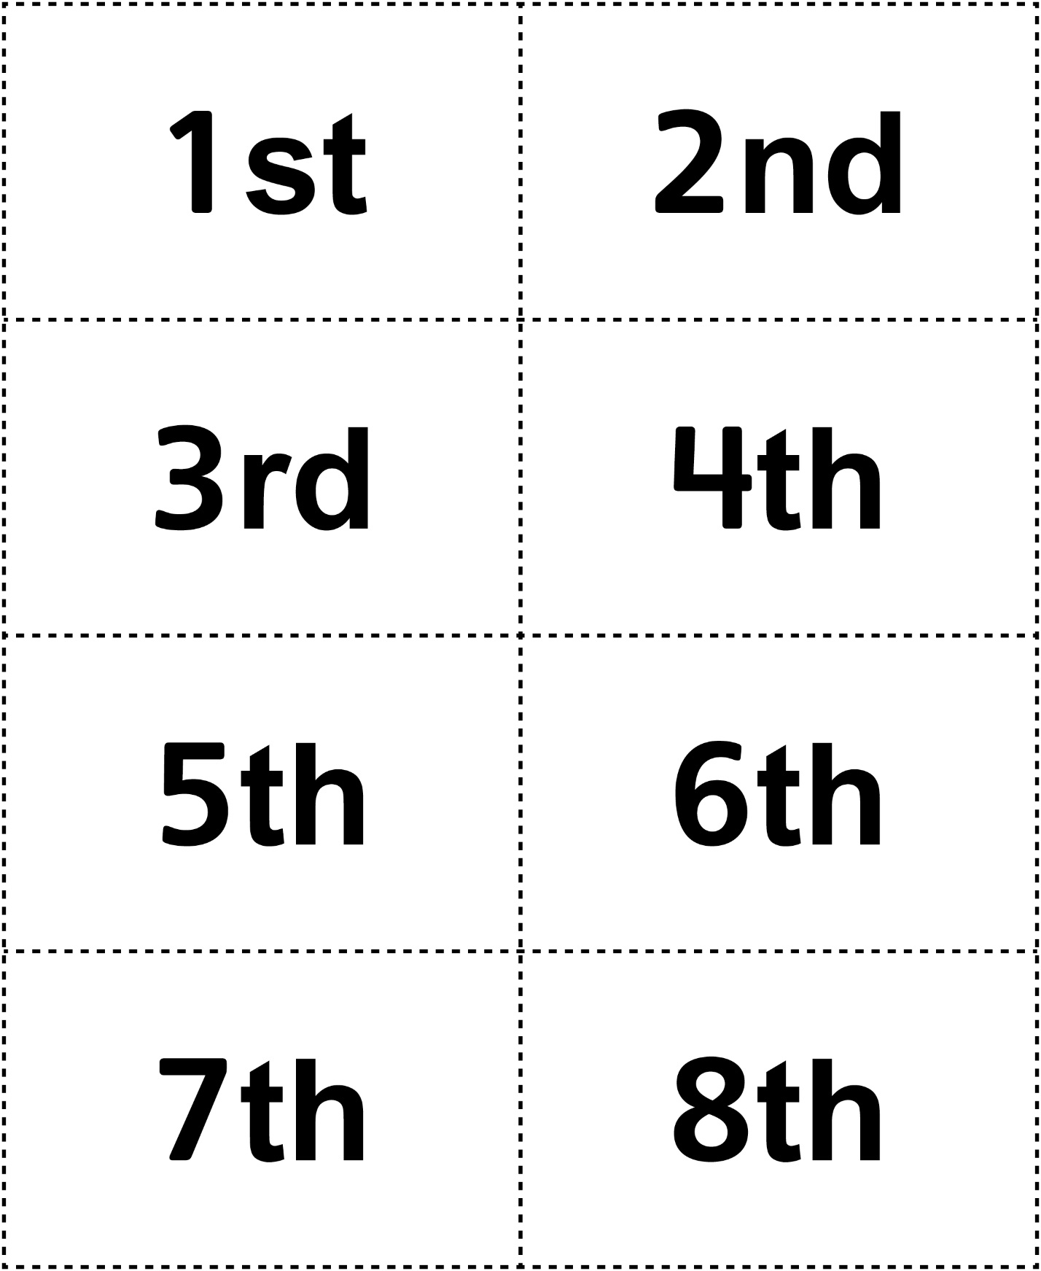



**Ordinal Number Cards**

**Master 20b**

