Comparing Capacities Behaviours/Strategies
Student thinks the tallest container holds the most. | 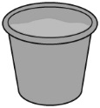  Student does not fill containers to the top. | 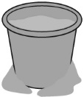  Student spills sand when pouring from one container to another.
Observations/Documentation
Student compares the capacity of each container to all others. | Student correctly orders the containers but has difficulty using measurement language to compare the capacities. | Student correctly orders the containers and uses measurement language to compare the capacities.
Observations/Documentation

