Describing Distance Behaviours/Strategies
Student does not recognize that the length between two points (places, people, objects) is distance.  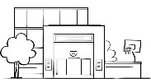 ? 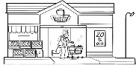 | Student has difficulty describing the distance between two points (places, people, objects).  ? 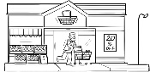  “The distance is…” | Student describes the distance between two points (places, people, objects) but in relative terms.  ? 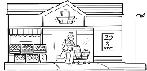  “The grocery store is closer to the school than the zoo.” | Student understands distance is the length between two points (places, people, objects) and uses measurement language (e.g., near, far away, short, long) to describe distance.  ? 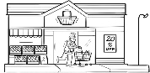  “The grocery store is near the school.”
Observations/Documentation

