Creating a Symmetrical Necklace/Bracelet Behaviours/Strategies
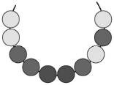  Student randomly places beads on the string, not giving any thought to symmetry. | 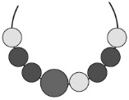  Student places more beads on one side of the large bead than on the other. | Student creates a design on one side of the large bead, then copies the design on the other side without making a mirror image.  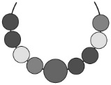
Observations/Documentation
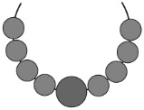  Student makes a symmetrical necklace/bracelet but uses only one colour, making it unclear if symmetry was considered. | 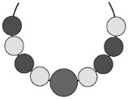  Student places most beads correctly but mixes up the order of a couple of beads. | 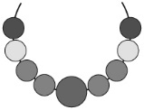  Student makes a symmetrical necklace/bracelet and explains why it is symmetrical with ease.
Observations/Documentation

