**Necklace/Bracelet Template**

**Master 47a**

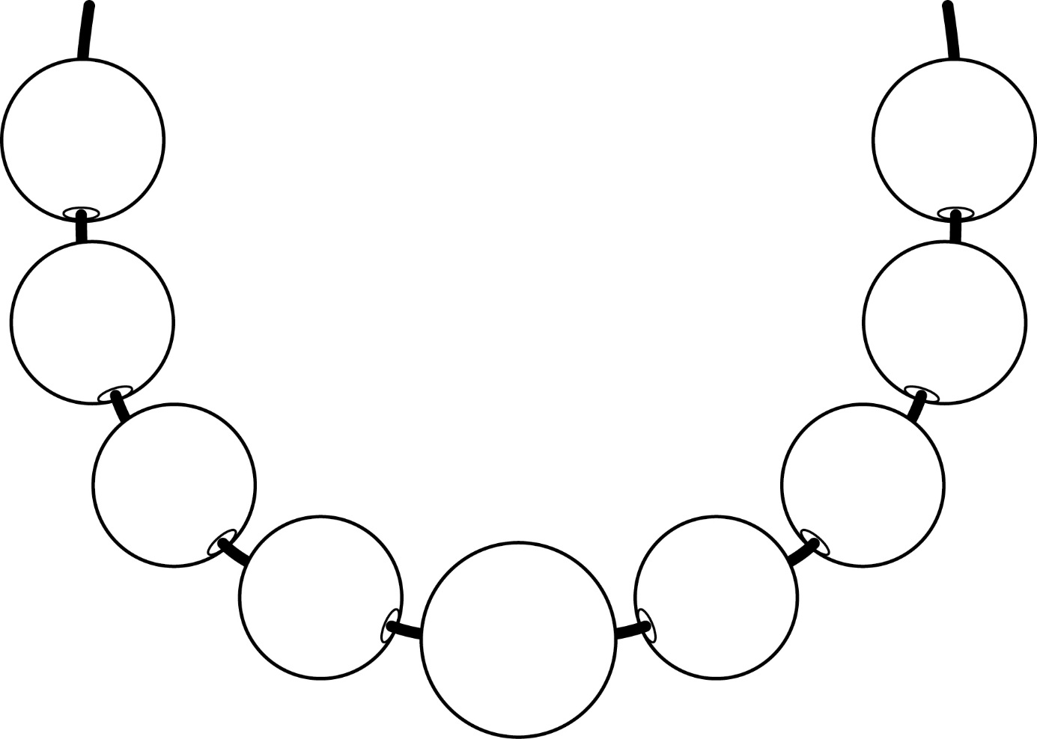

**Necklace/Bracelet Template**

**Master 47b**

