Identifying Lines of Symmetry Behaviours/Strategies
Student turns over a card but is unable to identify a line of symmetry on the 2-D shape.  “I don’t know how to find it.” | Student identifies and draws what he or she thinks is a line of symmetry, but does not fold the shape to check.  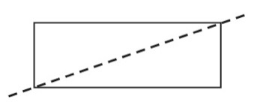 | Student identifies a line of symmetry, but does not realize that the shape has more than one line of symmetry.  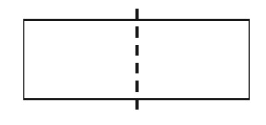
Observations/Documentation
Student identifies lines of symmetry on most 2-D shapes, but does not realize that a shape can have no lines of symmetry.  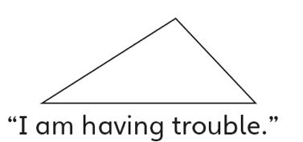 | Student identifies all lines of symmetry on 2-D shapes but struggles to sort the shapes on the sorting mat.  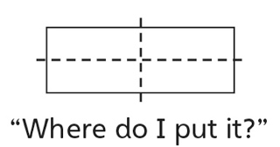 | Student successfully identifies all lines of symmetry on 2-D shapes and sorts them on the sorting mat.  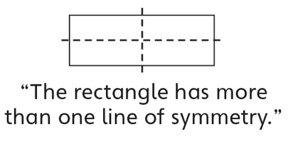
Observations/Documentation

