**Symmetry Cards**

**Master 43a**

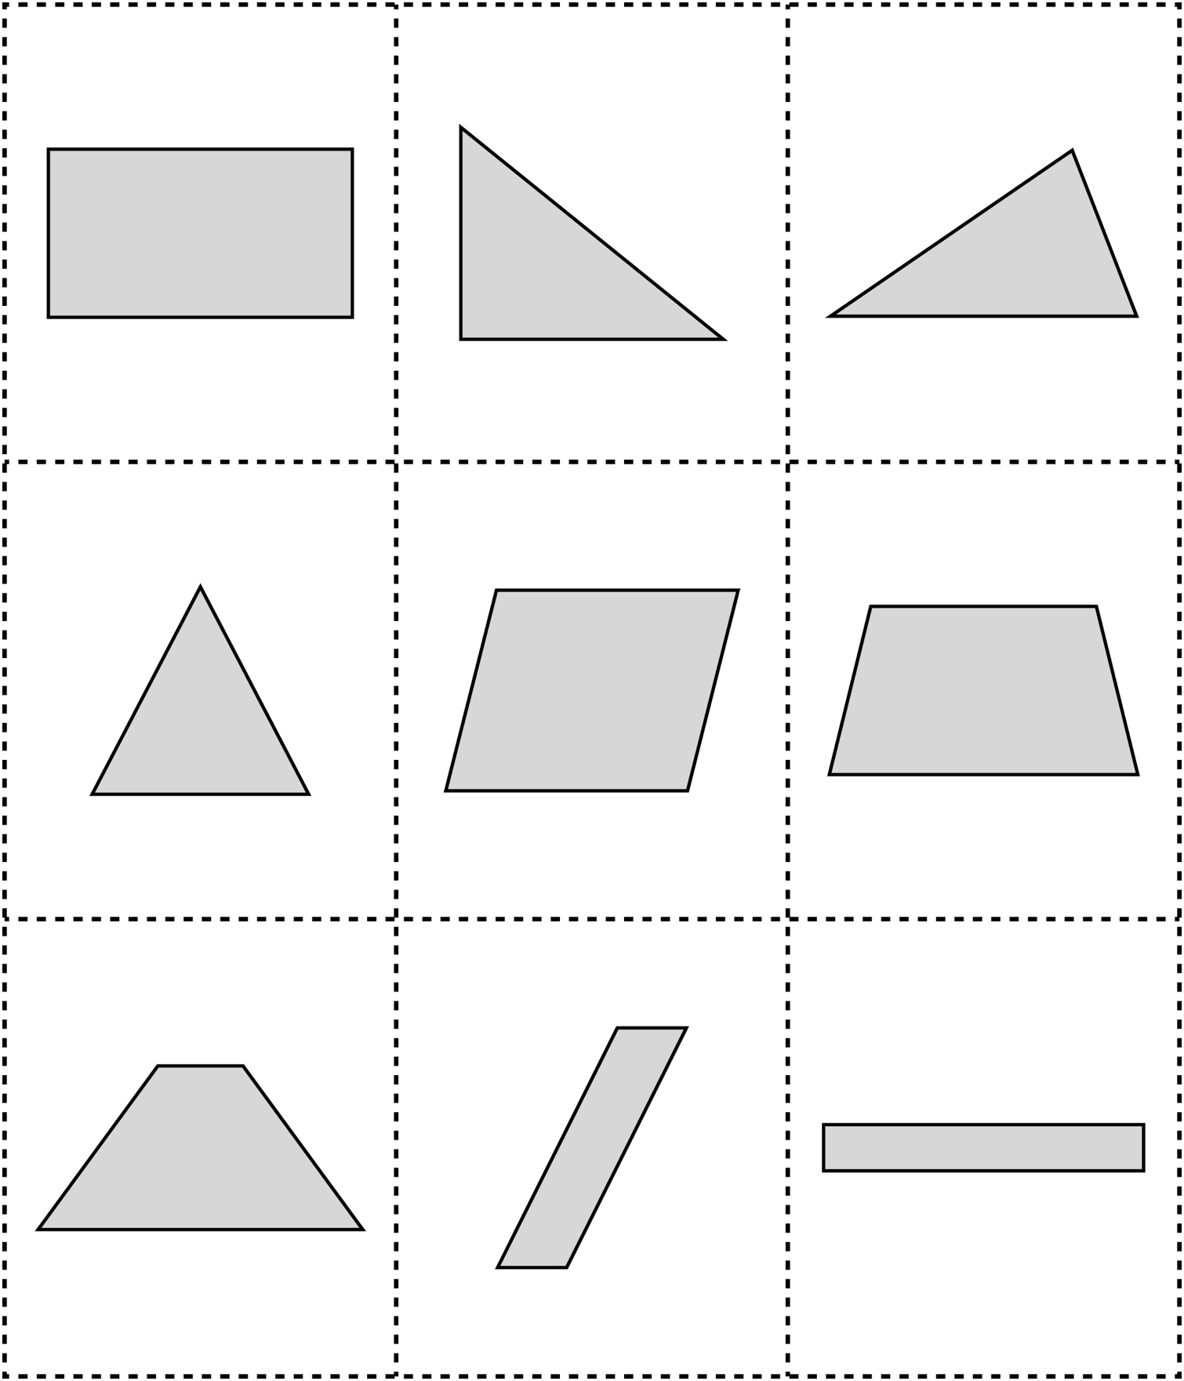

**Symmetry Cards (for Extension)**

**Master 43b**

