**Large Shapes (for *Before*)**

**Master 42a**

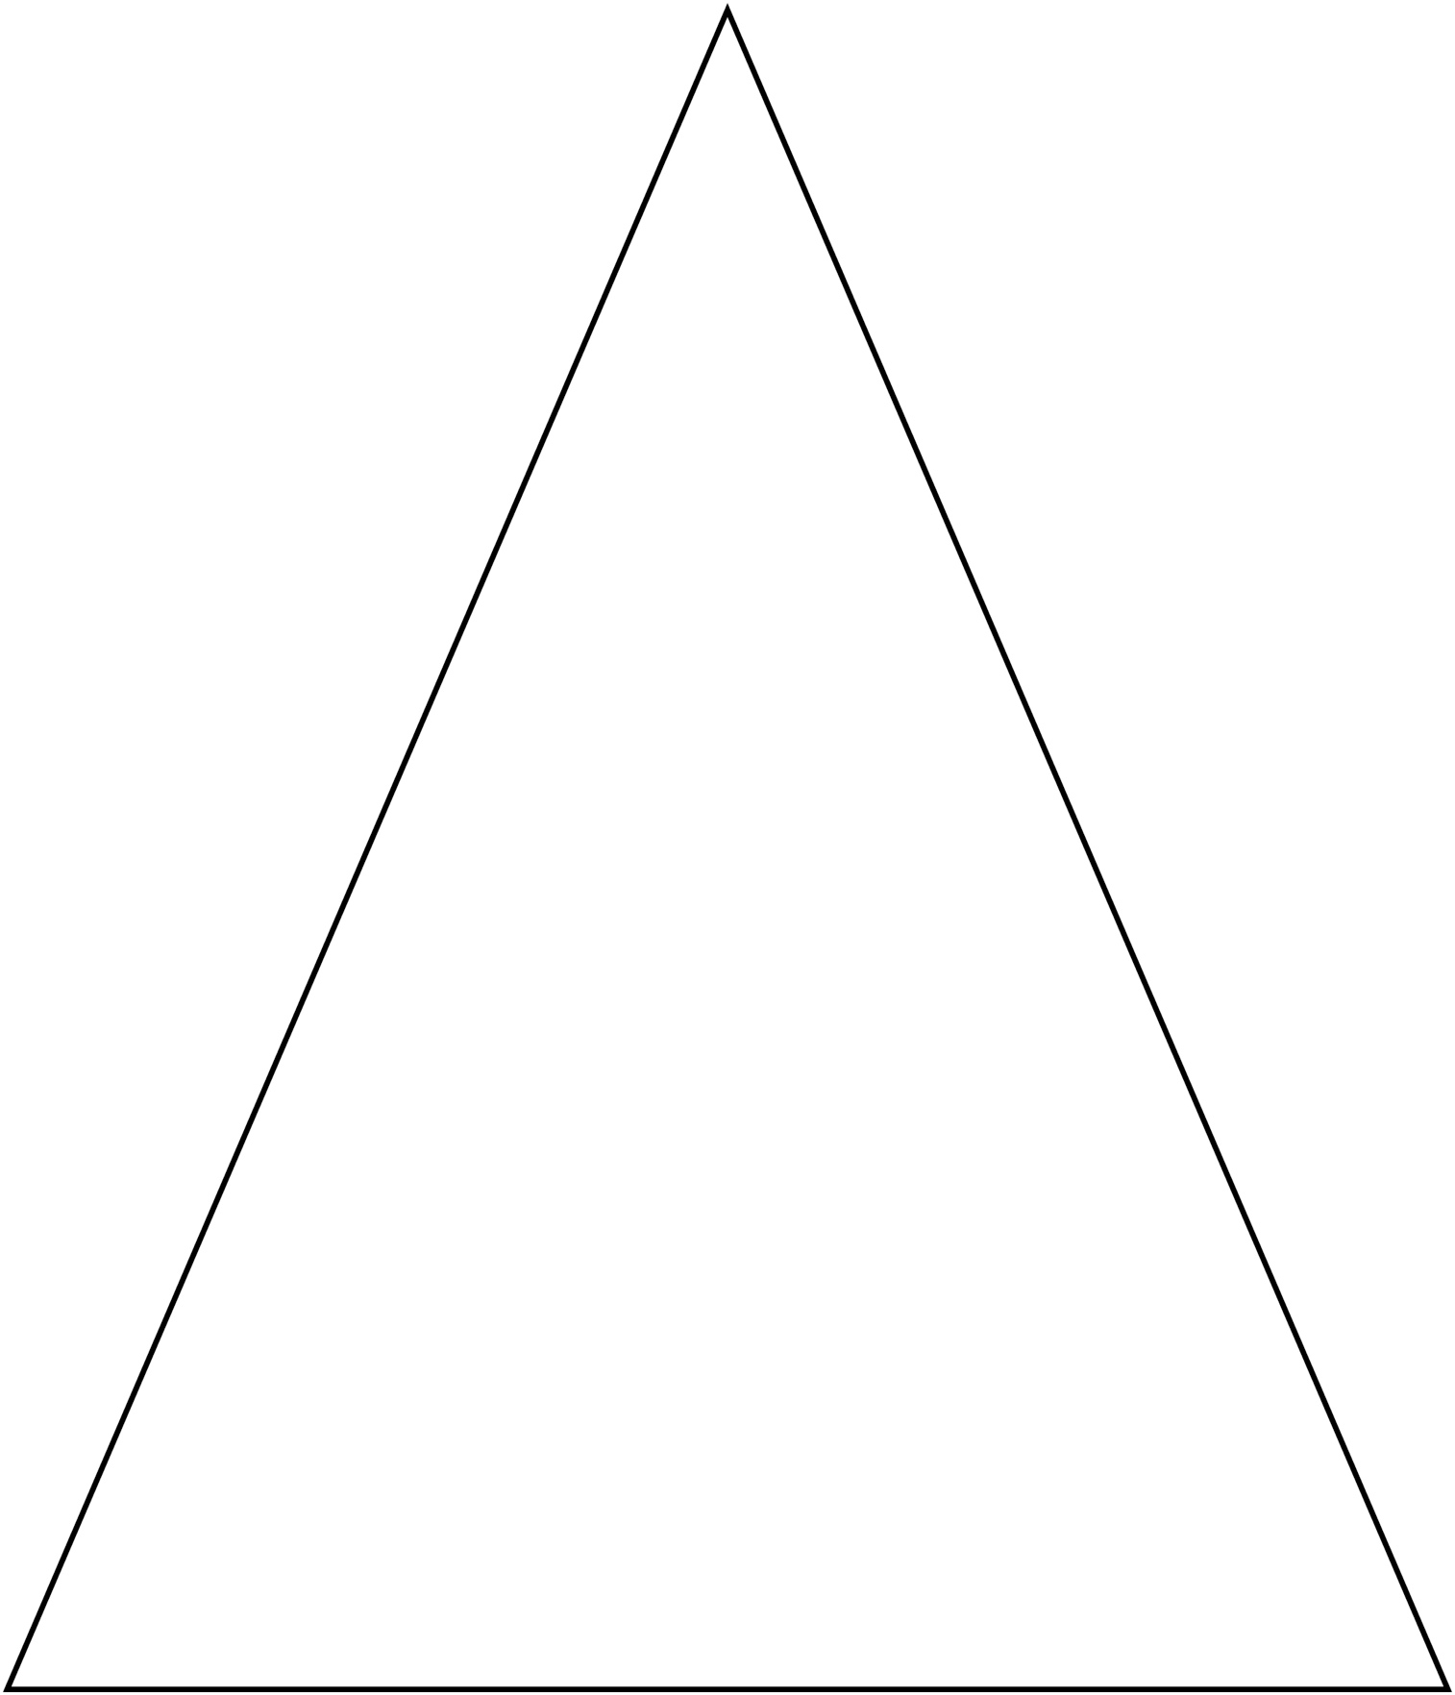

**Large Shapes (for *Before*)**

**Master 42b**

