**Symmetrical Images**

**Master 40a**

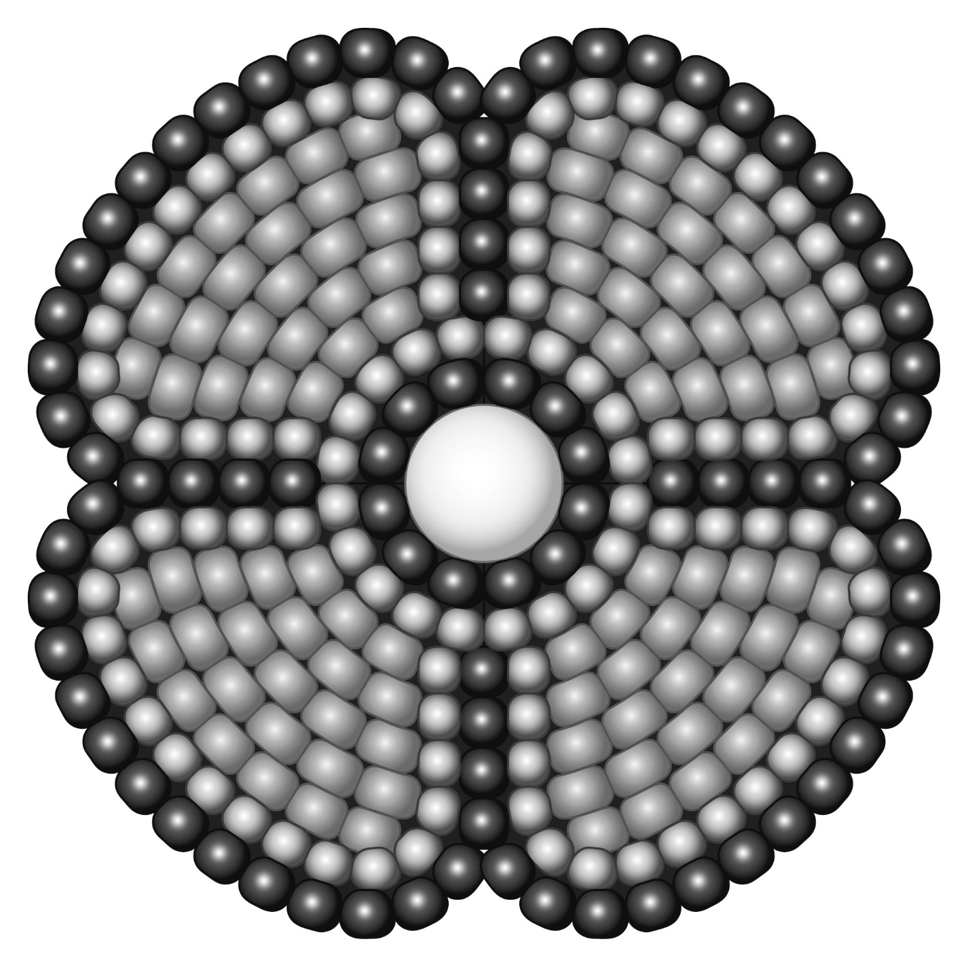

**Symmetrical Images**

**Master 40b**



**Symmetrical Images**

**Master 40c**



**Symmetrical Images**

**Master 40d**



**Symmetrical Images**

**Master 40e**

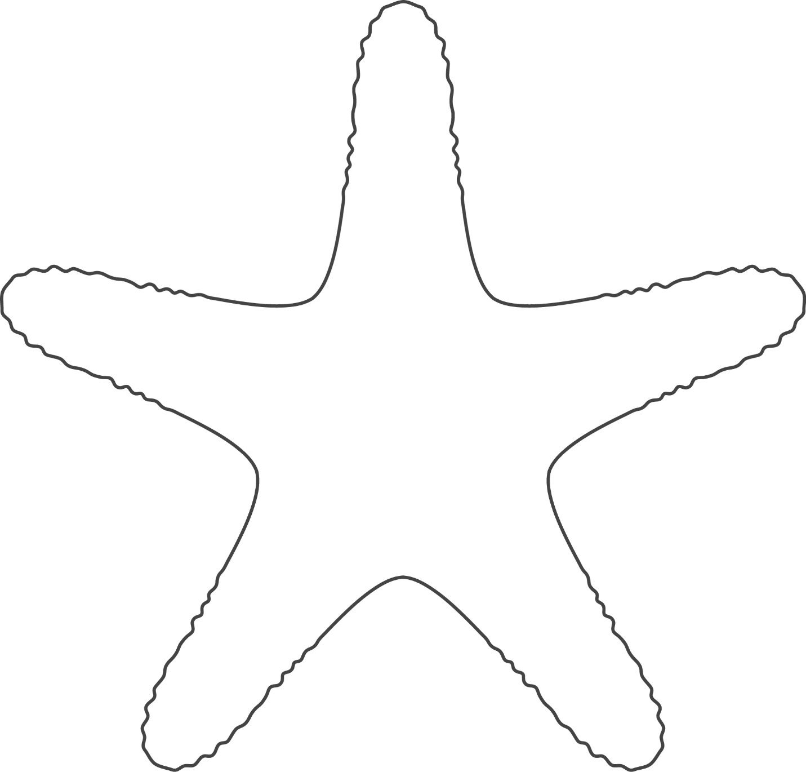

**Symmetrical Images**

**Master 40f**



**Symmetrical Images**

**Master 40g**



**Symmetrical Images**

**Master 40h**

