**Exploring Lines of Symmetry**

**Master 39a**



**Exploring Lines of Symmetry**

**Master 39b**



**Exploring Lines of Symmetry**

**Master 39c**

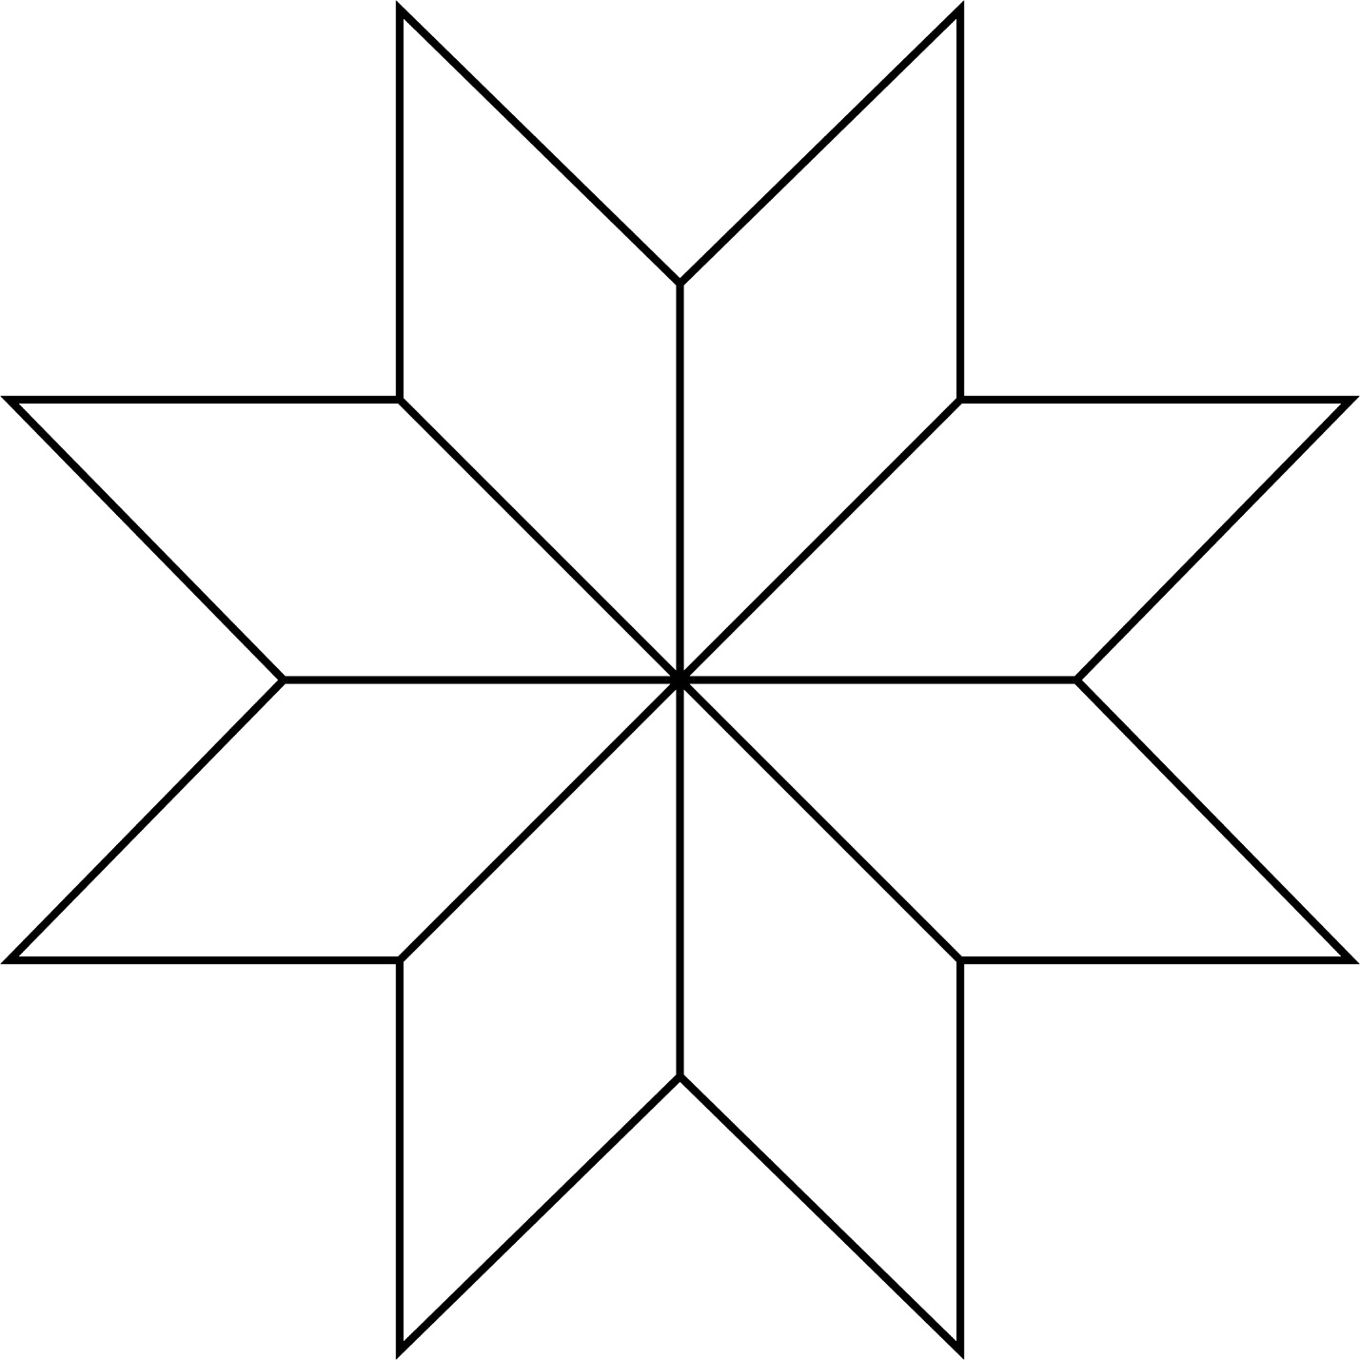

**Exploring Lines of Symmetry**

**Master 39d**

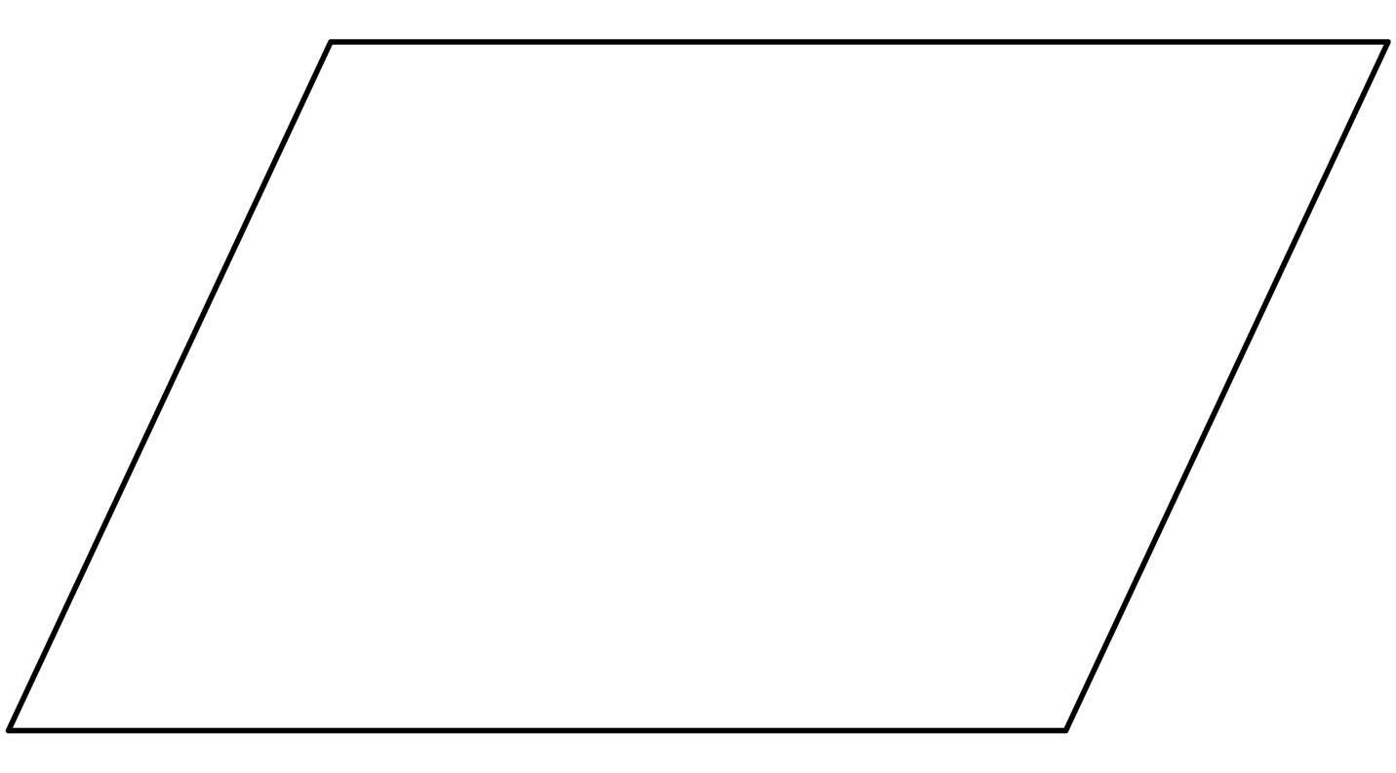

**Exploring Lines of Symmetry**

**Master 39e**

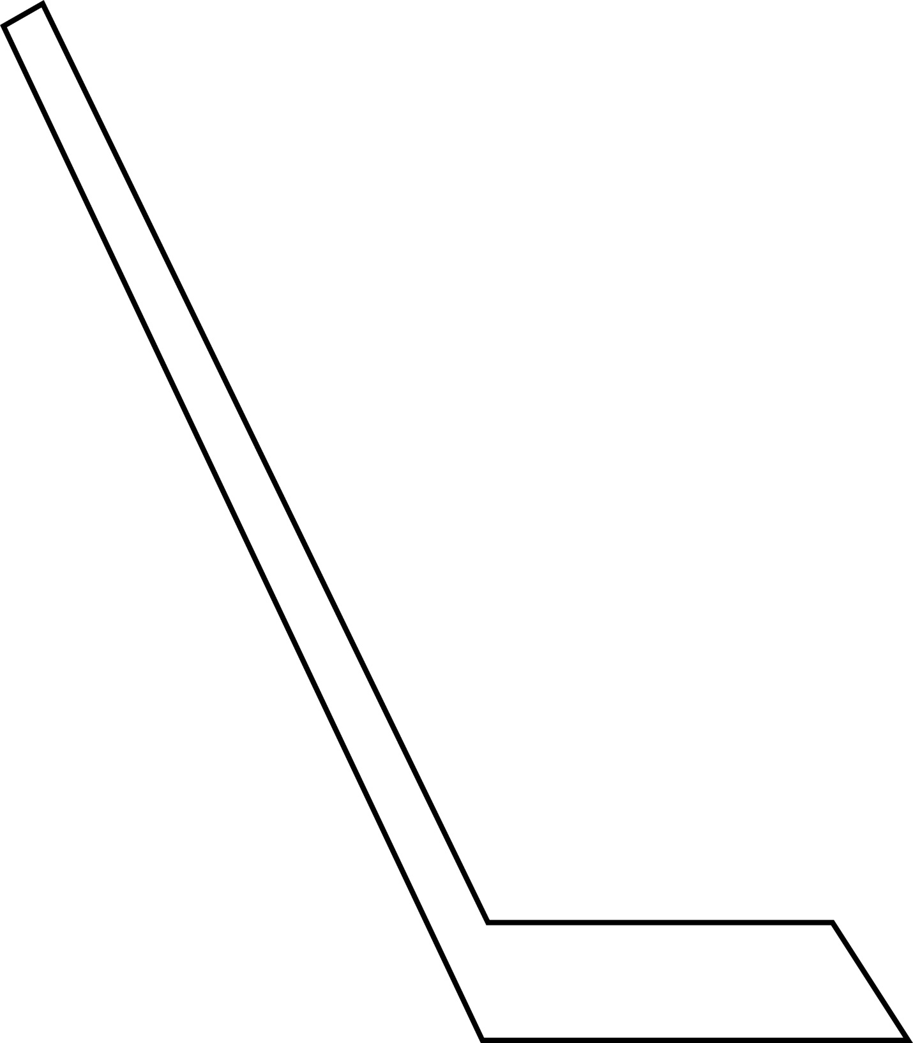

**Exploring Lines of Symmetry**

**Master 39f**

