Identifying Shapes Used to Create Outlines Behaviours/Strategies
Student is unable to predict which blocks were used to make the outline. | 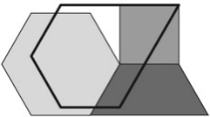  Student randomly places blocks in the outline with no thought to the lines. | 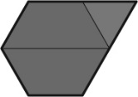  Student accurately places blocks in the outline, but thinks there is only one way to fill it. | Student accurately predicts the blocks used, fills the outline to check, and realizes there are many ways to fill it.
Observations/Documentation
Identifying Solids Used to Make Structures Behaviours/Strategies
Student uses gestures or non-geometric language to identify the solids.  “It looks like a party hat.” | Student knows the solids that were used but cannot name them by their mathematical names. | Student accurately names the solids but does not use geometric language to describe them. | Student uses geometric language with ease to name and describe the solids used.
Observations/Documentation

