**Made with Solids Cards**

**Master 36a**

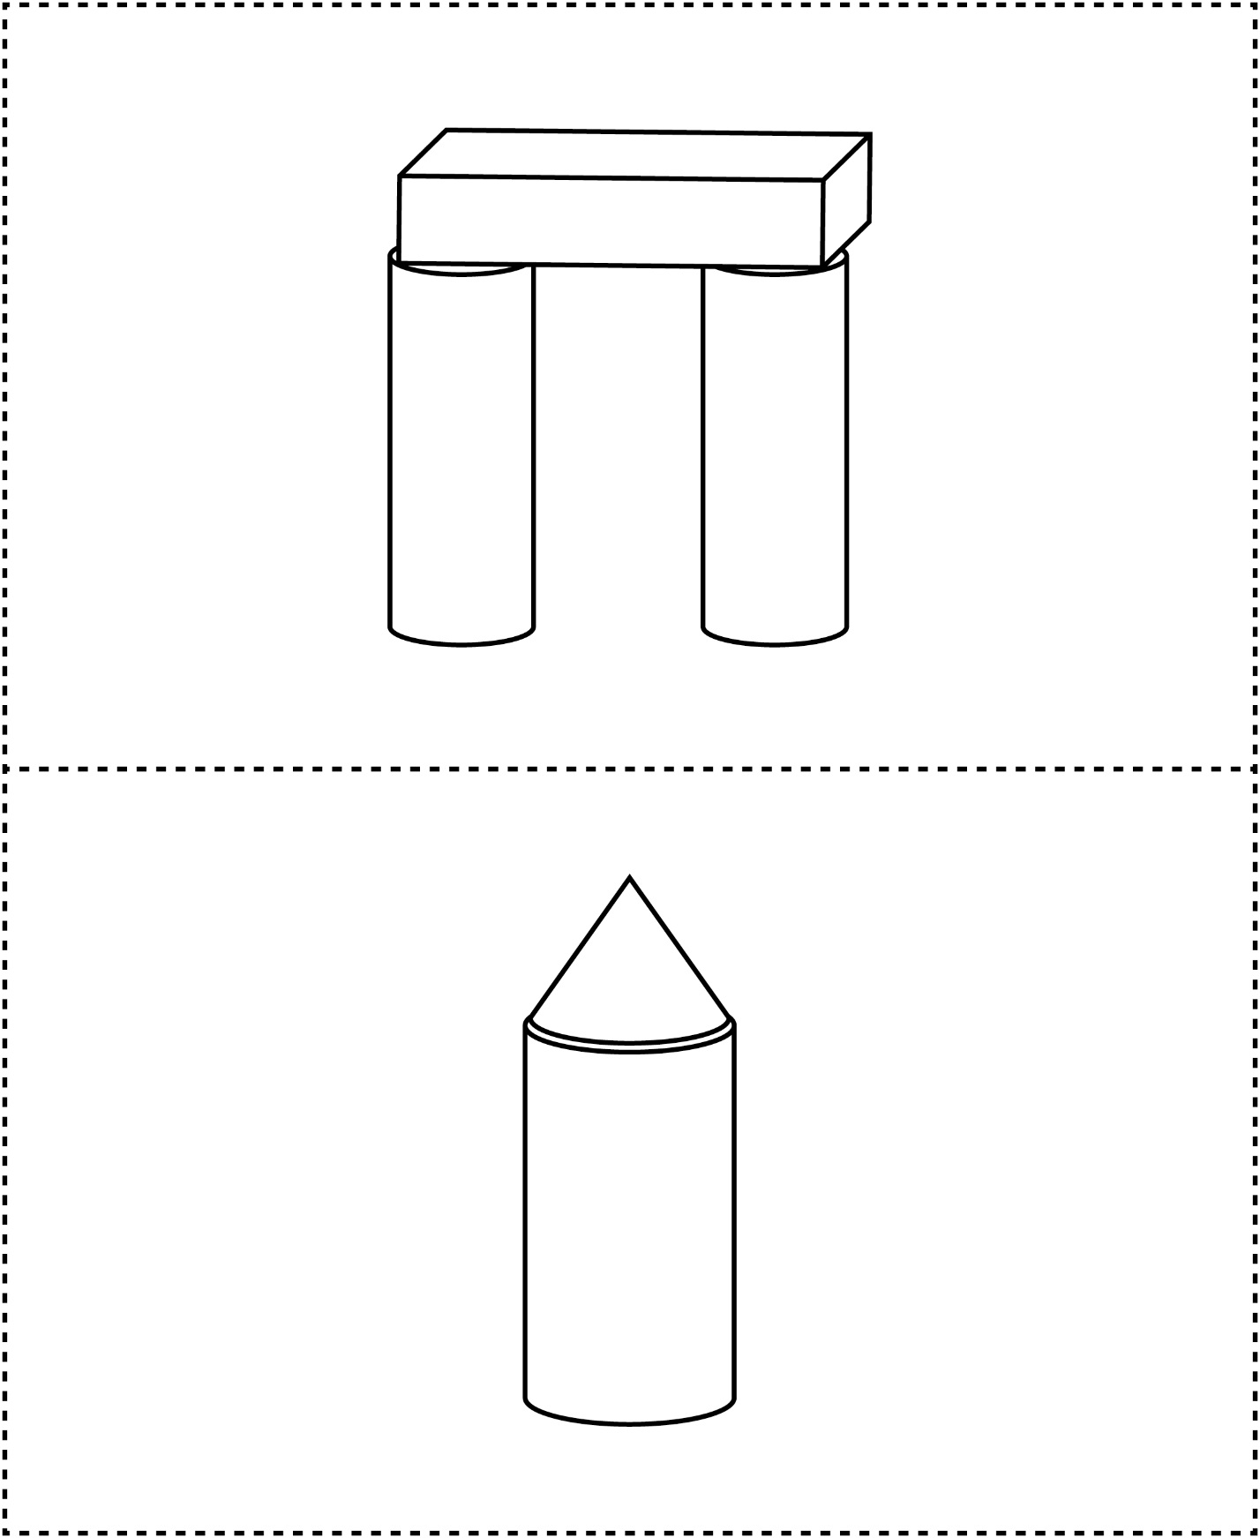



**Made with Solids Cards**

**Master 36b**

