**Shape Outline Cards**

**Master 35a**

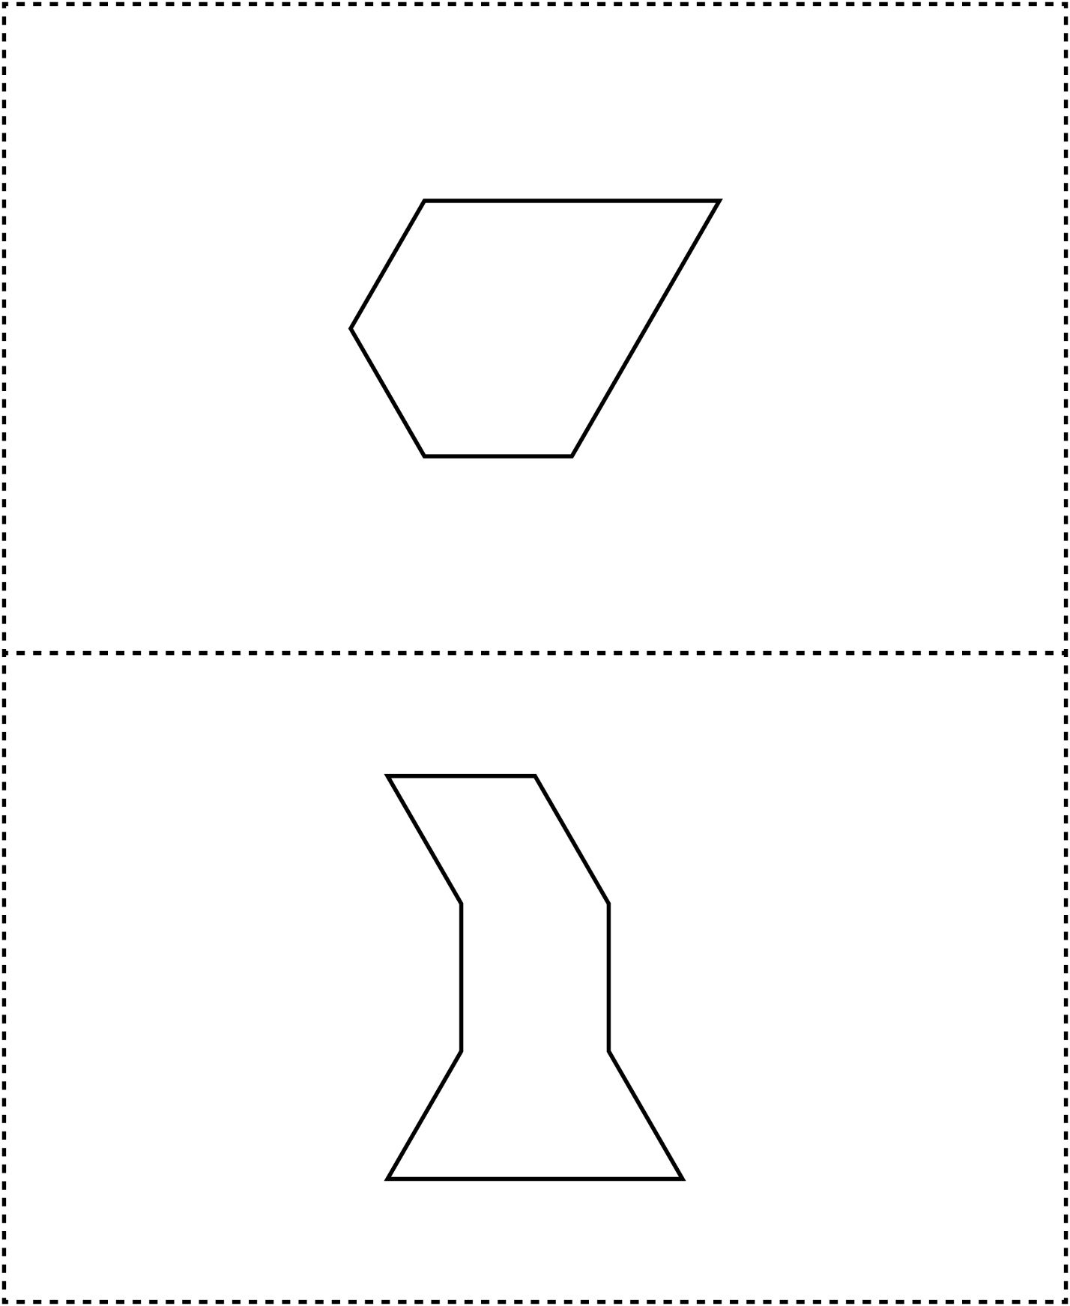



**Shape Outline Cards**

**Master 35b**

