Building Composite Structures Behaviours/Strategies
Student plays with 3-D solids, but does not know which solids to use to construct a composite structure. | Student constructs a composite structure with  3-D solids, but uses only one type of solid or only uses solids with square or rectangular faces.  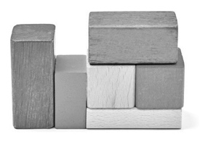 | Student constructs a composite structure with  3-D solids, but struggles to identify the solids used.  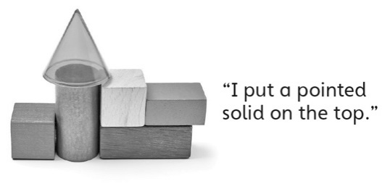
Observations/Documentation
Student constructs a composite structure with  3-D solids and identifies the solids used, but struggles to name the shapes of visible faces.  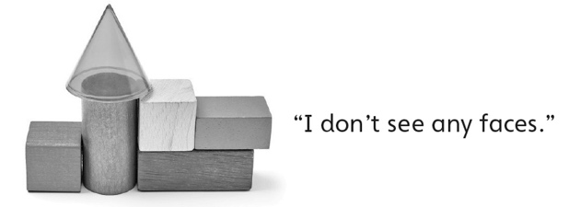 | Student constructs a composite structure with  3-D solids and identifies solids and faces, but struggles to compare structures. | Student successfully constructs a composite structure with 3-D solids, identifies solids and faces, and compares structures.  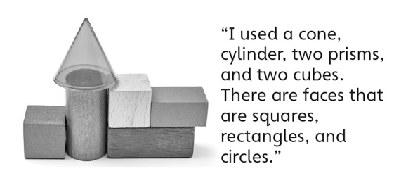
Observations/Documentation

