Our Structure
Master 33a

Stations 1 and 2
We built ____________________________________
Circle the solids you used.

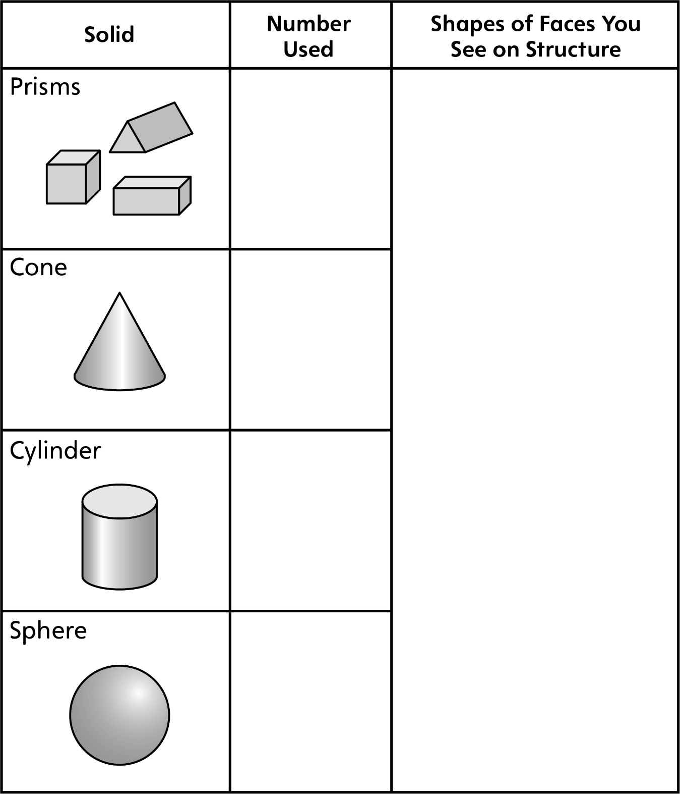
Our Structure
Master 33b

Station 3
We built ____________________________________

