***Find the Shapes* Designs**

**Master 29a**

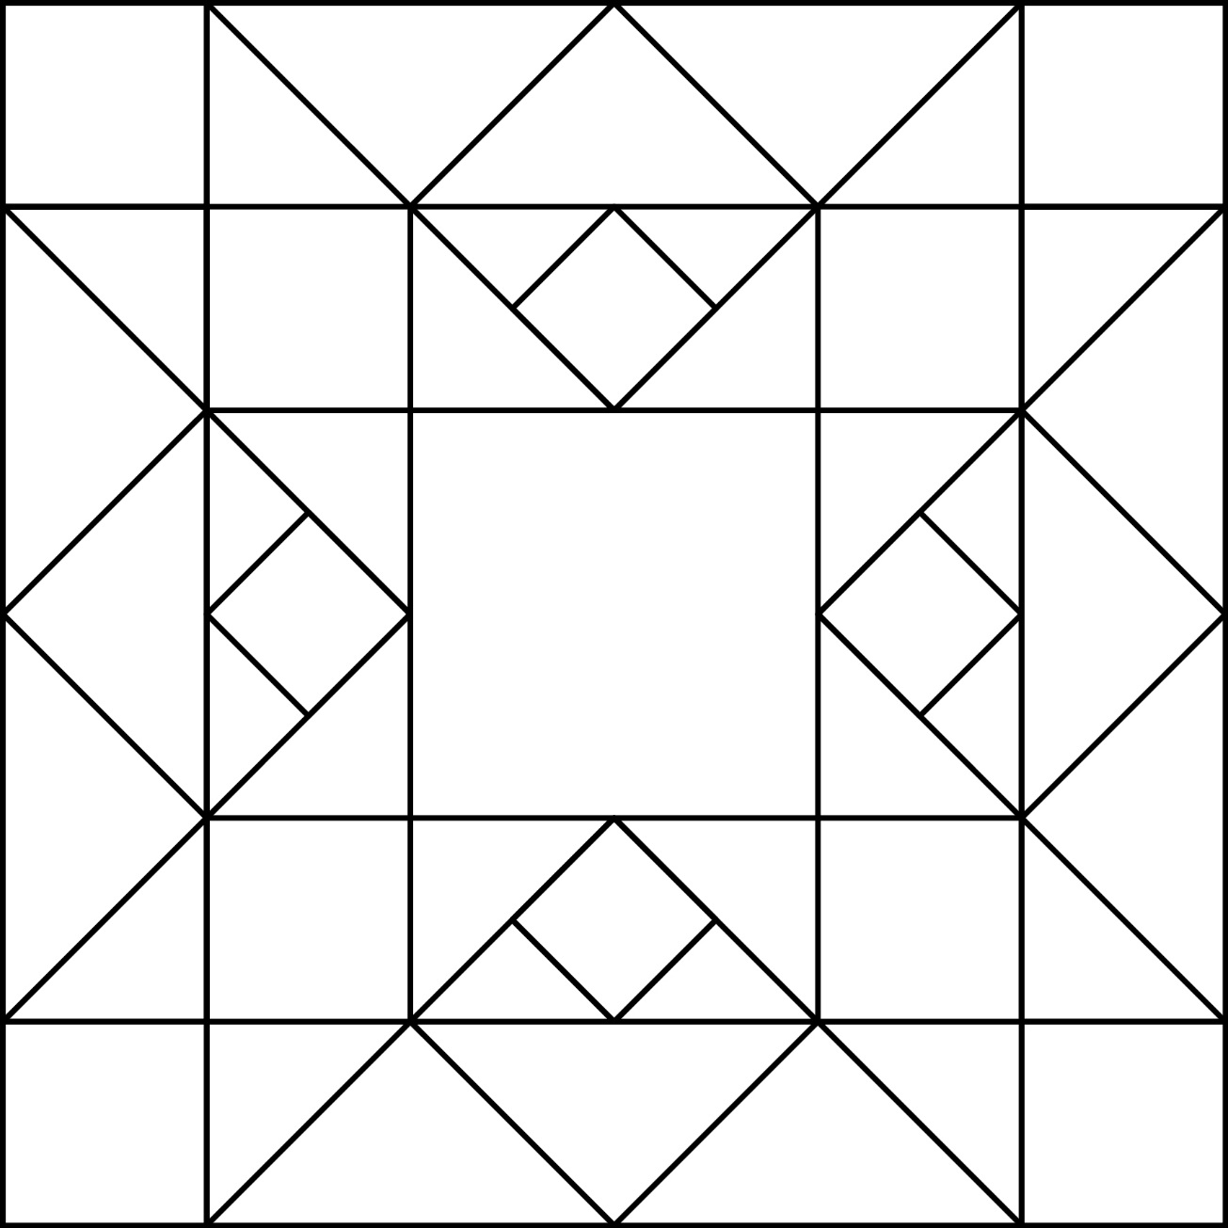

***Find the Shapes* Designs**

**Master 29b**

