Covering Outlines with Pattern Blocks Behaviours/Strategies
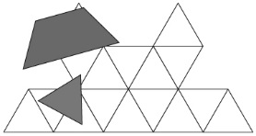  Student randomly places blocks on the outline with no thought to the lines shown. | 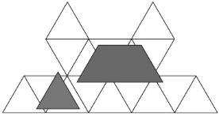  Student attempts to place the blocks without going over the lines. | Student has difficulty seeing shapes other than triangles in the outline.  “I don’t see where the yellow block can fit.”
Observations/Documentation
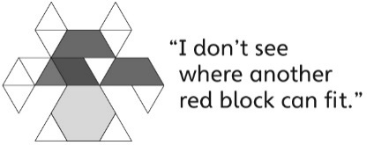  Student always tries to place the blocks in an upright position. | 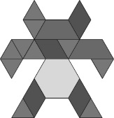  Student fits blocks within the lines to fill the outline, but thinks there is only one way to fill it. | Student fits blocks within the lines to fill the outline and realizes there are many ways to fill it.
Observations/Documentation

