Describing Solids Behaviours/Strategies
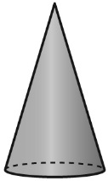  Student has difficulty describing solids. | Student uses only non-mathematical language to describe solids.  “It feels like a paper towel roll.” | Student uses general descriptions.  “It has corners.” | Student uses specific descriptions.  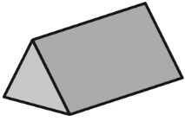  “It has triangles and rectangles, and it has six corners.”
Observations/Documentation
Identifying Solids Behaviours/Strategies
Student guesses the solid and ignores partner’s description.  “It is a ball; no, it’s a cylinder; no, it’s a cube ….”  Or student points randomly at solids. | Student focuses on only part of the description and is unable to correctly identify the solid.  “It has a face that is a circle. It is pointy. So it is a cylinder.” | 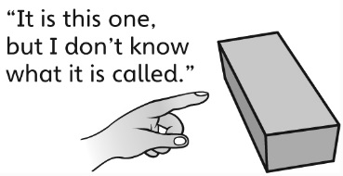  Student points to the correct solid but cannot call it by its proper name. | 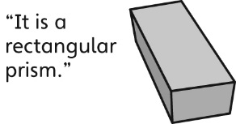  Student correctly identifies and names the solid.
Observations/Documentation

