Sorting Solids Behaviours/Strategies
Student is unable to select a solid based on the needed attribute. | 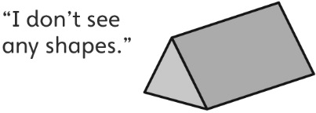  Student focuses on one shape and doesn’t realize that more than one shape can be a face of a solid. | 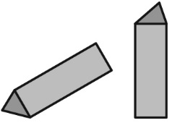  Student identifies some faces but doesn’t rotate the solid to see the different faces (shapes).
Observations/Documentation
Student recognizes some shapes but doesn’t recognize a shape when it doesn’t match her or his mental image of the shape.  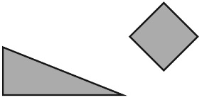 | 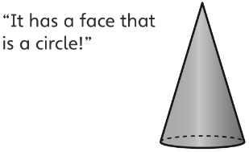  Student can only sort a solid in one way. | Student can sort solids with ease.
Observations/Documentation

