Sorting Shapes Behaviours/Strategies
Student randomly sorts shapes without thinking about attributes.  “I just put shapes in columns.  I didn’t use a rule.” | Student always sorts using non-geometric attributes (e.g., colour, size).  “I like to sort by size.” | Student sorts by appearance rather than attributes, and does not realize that the orientation of a shape does not matter.  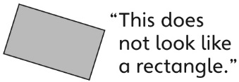 | Student sorts shapes using both geometric and non-geometric attributes.
Observations/Documentation
Identifying Sorting Rules Behaviours/Strategies
Student is unable to identify the sorting rule. | Student sorts the shapes but does not look at the shapes in the No column to confirm the sorting rule. | Student identifies the sorting rule but needs help communicating it. | Student identifies and describes the sorting rule.
Observations/Documentation

