Constructing 2-D Shapes Behaviours/Strategies
Student chooses materials, but struggles to construct 2-D shapes with given attributes (e.g., makes an open shape).  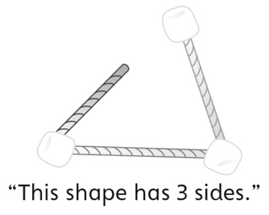 | Student constructs 2-D shapes with given attributes, but makes typical shapes (e.g., equilateral triangle).  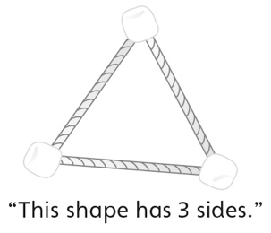 | Student constructs 2-D shapes with 4 sides, but struggles to name the shape.  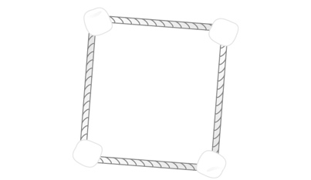
Observations/Documentation
Student constructs 2-D shapes with given attributes, but cannot describe how shapes are alike and how they are different.  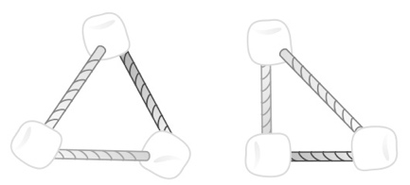 | Student constructs 2-D shapes with given attributes, but does not use math language to describe how shapes are alike and how they are different.  “They both have 3 points. One looks like a pizza slice and the other doesn’t.” | Student constructs 2-D shapes with given attributes and uses math language to describe how shapes are alike and how they are different.
Observations/Documentation

