Identifying Rectangles Behaviours/Strategies
Student does not have a mental image of a rectangle and cannot identify a rectangle. | Student only recognizes a rectangle when it is lying on one of its longer sides. | 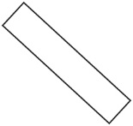  Student recognizes some rectangles but thinks that a rectangle that is oriented differently is not a rectangle.
Observations/Documentation
Student uses a shape’s appearance, not its geometric attributes, to identify a rectangle, and does not classify a square as a rectangle.  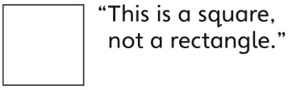 | Student successfully identifies rectangles but has difficulty communicating why a shape was put in a particular column. | Student successfully identifies rectangles and explains why a shape is or is not a rectangle.
Observations/Documentation

