Making Graphs Behaviours/Strategies
Student has difficulty sorting the objects into three groups. | 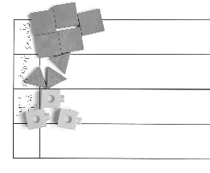  Student places objects or draws pictures in groups on the graph. | 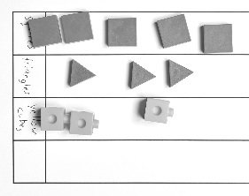  Student sorts in lines, but objects or pictures are not equally spaced and aligned. Pictures may be of different sizes. | 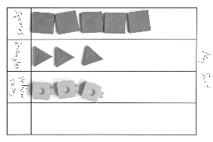  Student sorts in lines, all pictures are about the same size, and objects or pictures are equally spaced and aligned. Graph has a title and labels.
Observations/Documentation
Reading Graphs Behaviours/Strategies
Student has difficulty counting the number of objects in a column. | Student makes a pictograph or concrete graph but has difficulty reading data from the graph (e.g., “Which column has the most pictures or objects?”). | Student reads data from the graph but has difficulty comparing the data. | Student answers “how many” questions about the graph and compares data using terms such as “more,” “fewer,” “most,” and “least.”
Observations/Documentation

