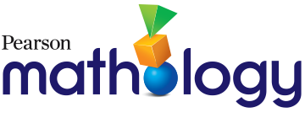
Mathology Grade 1 Correlation – Alberta
Master 1

Data Management Cluster 1: Data Management

Organizing Idea:
Statistics: The science of collecting, analyzing, visualizing, and interpreting data can inform understanding and decision making.
Guiding Question: How can data be used to answer questions about the world?
Learning Outcome: Students investigate and represent data.
Knowledge | Understanding | Skills & Procedures | Grade 1 Mathology | Mathology Little Books
Data can be collected information. | Data can be answers to questions. | Share wonderings about people, things, events, or experiences. | Data Management Cluster 1: Data Management  3: Data in Our World | Graph It!
 |  | Gather data by sharing answers to questions. | Data Management Cluster 1: Data Management  1: Making Concrete Graphs  2: Making Pictographs | Graph It!
A graph is a visual representation of data.  A graph can represent data by using objects, pictures, or numbers. | Data can be represented in a graph. | Collaborate to construct a concrete graph using data collected in the learning environment. | Data Management Cluster 1: Data Management  1: Making Concrete Graphs  4: Consolidation | Graph It!
 |  | Create a pictograph from a concrete graph. | Data Management Cluster 1: Data Management  2: Making Pictographs  4: Consolidation | Graph It!

