On sait perler ! Fiche reproductible 1
(fiche d’évaluation)
Nom : _____________________________

Décrire, prolonger et créer des régularités | Pas encore | Parfois | Souvent
Reconnaître et décrire des régularités
Reproduire et prolonger des régularités
Créer et décrire des suites
Classer des objets selon leurs attributs
Décrire les ressemblances et les différences entre des objets
Déterminer une règle de classement
Repérer les objets appartenant
à la même classe
Points forts :

Points à améliorer :

Activités à faire à la maison et lettre
aux parents / tuteurs Fiche reproductible 2–1
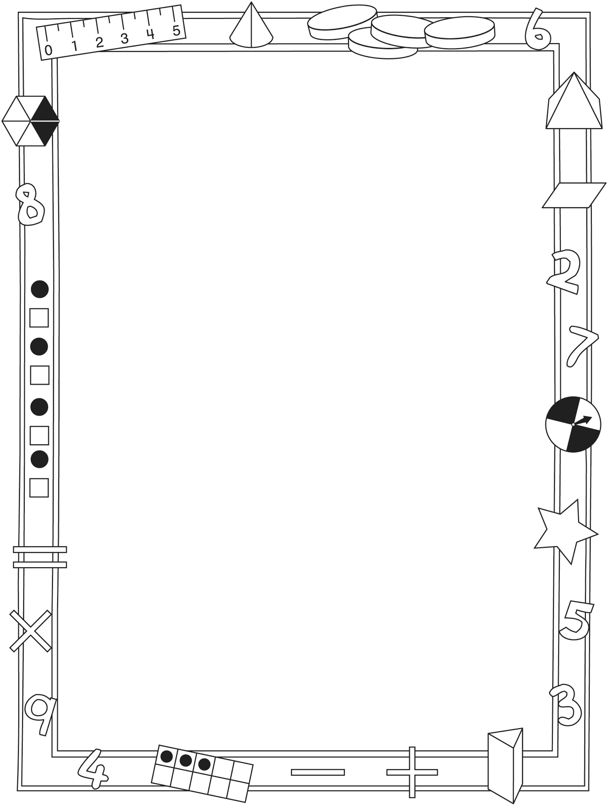

Note à l’enseignant(e)

Vous pouvez envoyer une lettre aux familles pour leur présenter le livret On sait perler ! et leur proposer quelques activités à faire à la maison avec leur enfant.

Composez votre lettre à l'aide de ce modèle et choisissez une ou deux activités proposées sur la Fiche 2-1 (l’activité en ligne) ou sur la Fiche 2-2. Il suffit de supprimer ces directives et de faire un copier-coller des activités choisies. Vous pouvez adapter ces activités en fonction de votre situation.

Vous aimeriez peut-être diriger les familles à notre site web www.pearsoncanada.ca/mlb/KP2-FR pour essayer de faire une activité interactive. Au besoin, il existe des notes pour les parents / enseignants pour l’activité, qui sont disponibles en anglais.

Activity Page 1
Math Focus: Sort objects by attributes
- Model how to use the math tool by dragging shapes around on the workspace.
- Encourage children to describe and group the shapes.
- Ask children to identify the shape that does not belong. Have them state a sorting rule to explain why.
- Prompt children to go to the next page.

Activity Page 2
- Ask children to identify which shape does not belong.
- Ask them to explain why it does not belong and encourage them to state a sorting rule.
- Invite children to sort the shapes another way. Have them explain a new reason why the shape does not belong.
- Challenge children to sort the shapes a third way. Ask why the shape does not belong now.

Activités à faire à la maison et lettre
aux parents / tuteurs Fiche reproductible 2–2

Chers parents / tuteurs,

Dans notre étude de ce livret On sait perler !, nous avons mis l’accent sur ces compétences en mathématiques : décrire, prolonger et créer des régularités et classer des objets selon leurs attributs. Nous vous suggérons ces activités à effectuer à la maison avec votre enfant.
– – – – – – – – – – – – – – – – – – – – – – – – – – – – – – – – – – – – – – – – – –
Lire l’histoire : En lisant cette histoire, encouragez votre enfant à décrire les perles et le motif créé dans chaque collier. Demandez-lui quelles perles il utiliserait pour prolonger le motif. Après la lecture, vous pouvez rassembler
un assortiment de perles ou de petits objets afin de créer vos propres motifs.
– – – – – – – – – – – – – – – – – – – – – – – – – – – – – – – – – – – – – – – – – –
Fabriquez un collier : Utilisez la Grille de mathématiques (à la couverture
arrière intérieure du livret) pour créer votre propre motif de collier. Disposez les perles en répétant le même motif et demandez à votre enfant de vous indiquer la partie qui se répète dans le collier. Amusez-vous ensemble à enfiler les perles et créez votre propre collier à motif.
– – – – – – – – – – – – – – – – – – – – – – – – – – – – – – – – – – – – – – – – – –
Qu’est-ce qui n’en fait pas partie ? Rassemblez 3 objets (une orange, une balle et un livre, par exemple) et demandez à votre enfant quel est l’objet qui ne fait pas partie du groupe (le livre, dans cet exemple). Invitez votre enfant à expliquer son raisonnement (l’orange et la balle sont rondes, le livre n’est pas rond). La règle de classement peut aussi être une fonction de l’objet : dans le groupe téléviseur-lampe-assiette, par exemple, l’assiette ne fait pas partie du groupe car elle ne consomme pas d’électricité. Encouragez votre enfant à vous montrer des ensembles de 3 objets que vous devrez classer de la même manière.
– – – – – – – – – – – – – – – – – – – – – – – – – – – – – – – – – – – – – – – – – –
Qu’est-ce qui vient ensuite ? Créez un début de suite en répétant le même motif au moins 3 fois. Invitez votre enfant à prolonger la suite et à expliquer son raisonnement. Demandez-lui de placer les éléments du motif un à la fois ou en segments de plusieurs éléments. Les suites de motifs peuvent être des dessins, des objets, des gestes (tapement de mains) ou des mots prononcés ou chantés à voix haute.
– – – – – – – – – – – – – – – – – – – – – – – – – – – – – – – – – – – – – – – – – –

Sincèrement,

___________________________

Connecting Home and School Fiche reproductible 2–3

Dear Family:

We have been working on We Can Bead! which focuses on describing, extending, and creating repeating patterns and sorting objects by attributes.
Try this activity at home with your child.
– – – – – – – – – – – – – – – – – – – – – – – – – – – – – – – – – – – – – – – – – –
Reading the Story: As you read the story, encourage your child to describe the beads and the pattern on each necklace. Invite your child to predict what comes next in each pattern. After you read, you might gather beads or other household objects to make your own patterns.
– – – – – – – – – – – – – – – – – – – – – – – – – – – – – – – – – – – – – – – – – –
Make Your Own Necklace: Use the Math Mat on the inside back cover of We Can Bead! to plan your own necklace pattern. Arrange beads into a repeating pattern and invite your child to identify the part of the pattern that repeats. Then work together to string the beads and create your own patterned necklace.
– – – – – – – – – – – – – – – – – – – – – – – – – – – – – – – – – – – – – – – – – –
What Does Not Belong? List 3 objects that are around you (e.g., orange, basketball, book) and ask your child which one does not belong with the other 2 (e.g., book). Invite your child to explain her/his thinking (e.g., oranges and basketballs are round; the book is not round). Sorting rules can also include function (e.g., television, light, dish: a dish does not belong because it does not use electricity or turn on). Encourage your child to suggest sets of 3 objects for you to solve.
– – – – – – – – – – – – – – – – – – – – – – – – – – – – – – – – – – – – – – – – – –
What Comes Next? Start a pattern with a repeating part that appears at least 3 times. Invite your child to extend the pattern and explain his/her thinking. Have your child add pattern pieces one at a time or in longer segments. Patterns can be drawn, made with objects, clapped, or said aloud.
– – – – – – – – – – – – – – – – – – – – – – – – – – – – – – – – – – – – – – – – – –

Sincerely,

___________________________

Grille de mathématiques Fiche reproductible 3
On sait perler !

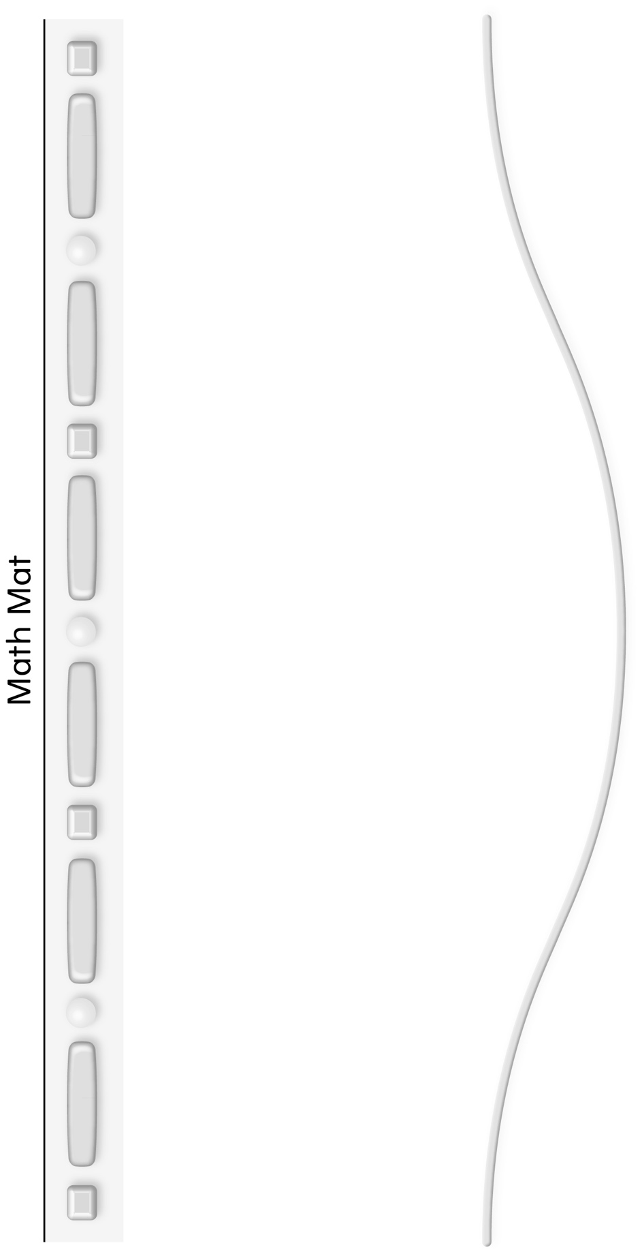

Quel objet ne fait pas Fiche reproductible 4
partie du groupe ?
Nom : _____________________________

Sac | Quels objets en font  partie ? | Quel objet n’en fait pas partie ?

Bandes de régularités Fiche reproductible 5–1
– – – – – – – – – – – – – – – – – – – – – – – – – – – – – – – – – – – – – – – – – – – – – – – – – – – – – – – – – – –
– – – – – – – – – – – – – – – – – – – – – – – – – – – – – – – – – – – – – – – – – – – – – – – – – – – – – – – – – – –
– – – – – – – – – – – – – – – – – – – – – – – – – – – – – – – – – – – – – – – – – – – – – – – – – – – – – – – – – – –
– – – – – – – – – – – – – – – – – – – – – – – – – – – – – – – – – – – – – – – – – – – – – – – – – – – – – – – – – – –

Bandes de régularités Fiche reproductible 5–2
– – – – – – – – – – – – – – – – – – – – – – – – – – – – – – – – – – – – – – – – – – – – – – – – – – – – – – – – – – –
– – – – – – – – – – – – – – – – – – – – – – – – – – – – – – – – – – – – – – – – – – – – – – – – – – – – – – – – – – –
– – – – – – – – – – – – – – – – – – – – – – – – – – – – – – – – – – – – – – – – – – – – – – – – – – – – – – – – – – –
– – – – – – – – – – – – – – – – – – – – – – – – – – – – – – – – – – – – – – – – – – – – – – – – – – – – – – – – – – –

Bandes de régularités Fiche reproductible 5–3
– – – – – – – – – – – – – – – – – – – – – – – – – – – – – – – – – – – – – – – – – – – – – – – – – – – – – – – – – – –
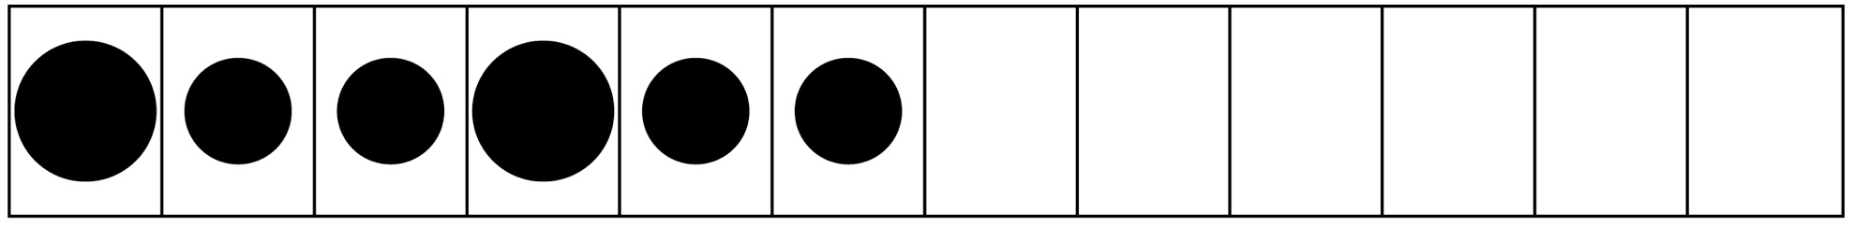
– – – – – – – – – – – – – – – – – – – – – – – – – – – – – – – – – – – – – – – – – – – – – – – – – – – – – – – – – – –
– – – – – – – – – – – – – – – – – – – – – – – – – – – – – – – – – – – – – – – – – – – – – – – – – – – – – – – – – – –
– – – – – – – – – – – – – – – – – – – – – – – – – – – – – – – – – – – – – – – – – – – – – – – – – – – – – – – – – – –

Bandes de régularités Fiche reproductible 5–4
– – – – – – – – – – – – – – – – – – – – – – – – – – – – – – – – – – – – – – – – – – – – – – – – – – – – – – – – – – –
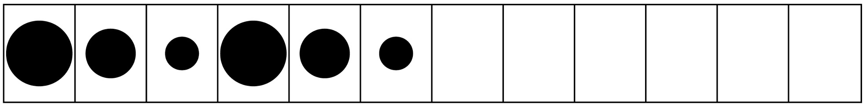
– – – – – – – – – – – – – – – – – – – – – – – – – – – – – – – – – – – – – – – – – – – – – – – – – – – – – – – – – – –
– – – – – – – – – – – – – – – – – – – – – – – – – – – – – – – – – – – – – – – – – – – – – – – – – – – – – – – – – – –
– – – – – – – – – – – – – – – – – – – – – – – – – – – – – – – – – – – – – – – – – – – – – – – – – – – – – – – – – – –

Bandes de régularités Fiche reproductible 5–5
– – – – – – – – – – – – – – – – – – – – – – – – – – – – – – – – – – – – – – – – – – – – – – – – – – – – – – – – – – –
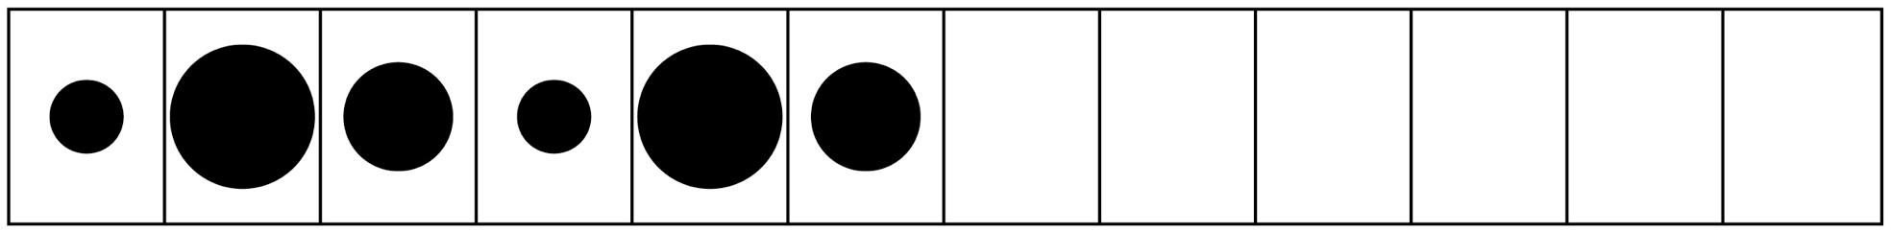
– – – – – – – – – – – – – – – – – – – – – – – – – – – – – – – – – – – – – – – – – – – – – – – – – – – – – – – – – – –
– – – – – – – – – – – – – – – – – – – – – – – – – – – – – – – – – – – – – – – – – – – – – – – – – – – – – – – – – – –
– – – – – – – – – – – – – – – – – – – – – – – – – – – – – – – – – – – – – – – – – – – – – – – – – – – – – – – – – – –

Bandes de régularités Fiche reproductible 5–6
– – – – – – – – – – – – – – – – – – – – – – – – – – – – – – – – – – – – – – – – – – – – – – – – – – – – – – – – – – –
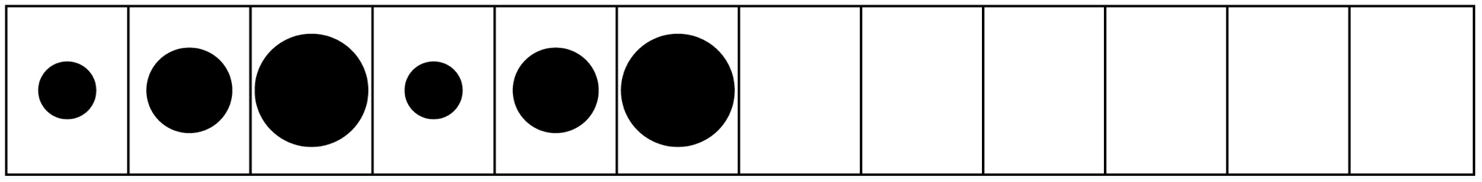
– – – – – – – – – – – – – – – – – – – – – – – – – – – – – – – – – – – – – – – – – – – – – – – – – – – – – – – – – – –
– – – – – – – – – – – – – – – – – – – – – – – – – – – – – – – – – – – – – – – – – – – – – – – – – – – – – – – – – – –
– – – – – – – – – – – – – – – – – – – – – – – – – – – – – – – – – – – – – – – – – – – – – – – – – – – – – – – – – – –

Bandes de régularités Fiche reproductible 5–7
– – – – – – – – – – – – – – – – – – – – – – – – – – – – – – – – – – – – – – – – – – – – – – – – – – – – – – – – – – –
– – – – – – – – – – – – – – – – – – – – – – – – – – – – – – – – – – – – – – – – – – – – – – – – – – – – – – – – – – –
– – – – – – – – – – – – – – – – – – – – – – – – – – – – – – – – – – – – – – – – – – – – – – – – – – – – – – – – – – –
– – – – – – – – – – – – – – – – – – – – – – – – – – – – – – – – – – – – – – – – – – – – – – – – – – – – – – – – – – –

Bandes de régularités Fiche reproductible 5–8
– – – – – – – – – – – – – – – – – – – – – – – – – – – – – – – – – – – – – – – – – – – – – – – – – – – – – – – – – – –
– – – – – – – – – – – – – – – – – – – – – – – – – – – – – – – – – – – – – – – – – – – – – – – – – – – – – – – – – – –
– – – – – – – – – – – – – – – – – – – – – – – – – – – – – – – – – – – – – – – – – – – – – – – – – – – – – – – – – – –
– – – – – – – – – – – – – – – – – – – – – – – – – – – – – – – – – – – – – – – – – – – – – – – – – – – – – – – – – – –

Bandes de régularités Fiche reproductible 5–9
– – – – – – – – – – – – – – – – – – – – – – – – – – – – – – – – – – – – – – – – – – – – – – – – – – – – – – – – – – –
– – – – – – – – – – – – – – – – – – – – – – – – – – – – – – – – – – – – – – – – – – – – – – – – – – – – – – – – – – –
– – – – – – – – – – – – – – – – – – – – – – – – – – – – – – – – – – – – – – – – – – – – – – – – – – – – – – – – – – –
– – – – – – – – – – – – – – – – – – – – – – – – – – – – – – – – – – – – – – – – – – – – – – – – – – – – – – – – – – –

Bandes de régularités Fiche reproductible 5–10
– – – – – – – – – – – – – – – – – – – – – – – – – – – – – – – – – – – – – – – – – – – – – – – – – – – – – – – – – – –
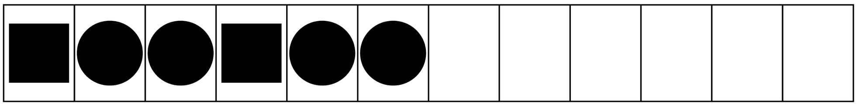
– – – – – – – – – – – – – – – – – – – – – – – – – – – – – – – – – – – – – – – – – – – – – – – – – – – – – – – – – – –
– – – – – – – – – – – – – – – – – – – – – – – – – – – – – – – – – – – – – – – – – – – – – – – – – – – – – – – – – – –
– – – – – – – – – – – – – – – – – – – – – – – – – – – – – – – – – – – – – – – – – – – – – – – – – – – – – – – – – – –

Bandes de régularités Fiche reproductible 5–11
– – – – – – – – – – – – – – – – – – – – – – – – – – – – – – – – – – – – – – – – – – – – – – – – – – – – – – – – – – –
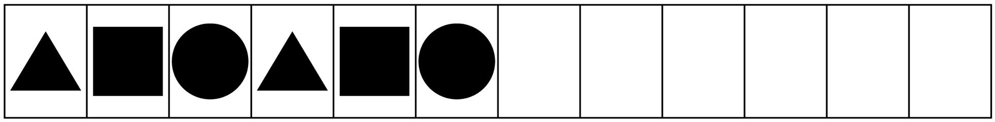
– – – – – – – – – – – – – – – – – – – – – – – – – – – – – – – – – – – – – – – – – – – – – – – – – – – – – – – – – – –
– – – – – – – – – – – – – – – – – – – – – – – – – – – – – – – – – – – – – – – – – – – – – – – – – – – – – – – – – – –
– – – – – – – – – – – – – – – – – – – – – – – – – – – – – – – – – – – – – – – – – – – – – – – – – – – – – – – – – – –

Bandes de régularités Fiche reproductible 5–12
– – – – – – – – – – – – – – – – – – – – – – – – – – – – – – – – – – – – – – – – – – – – – – – – – – – – – – – – – – –
– – – – – – – – – – – – – – – – – – – – – – – – – – – – – – – – – – – – – – – – – – – – – – – – – – – – – – – – – – –
– – – – – – – – – – – – – – – – – – – – – – – – – – – – – – – – – – – – – – – – – – – – – – – – – – – – – – – – – – –
– – – – – – – – – – – – – – – – – – – – – – – – – – – – – – – – – – – – – – – – – – – – – – – – – – – – – – – – – – –

Grille de classement Fiche reproductible 6–1
Nom : _____________________________

La règle de classement :

Grille de classement Fiche reproductible 6–2
Nom : _____________________________

Grille de classement Fiche reproductible 6–3
Nom : _____________________________

Grille de classement Fiche reproductible 6–4
Nom : _____________________________

Modèle de mini-livret Fiche reproductible 7

Le motif de mon collier  par ______________ | Voici la partie qui se répète dans ma suite.
Ma suite est une suite qui se répète. | Voici mon collier !

Problèmes de motifs Fiche reproductible 8–1
– – – – – – – – – – – – – – – – – – – – – – – – – – – – – – – – – – – – – – – – – – – – – – – – – – – – – – – – – – –

Encercle la partie de la suite qui se répète. Quelle est la forme suivante ?

– – – – – – – – – – – – – – – – – – – – – – – – – – – – – – – – – – – – – – – – – – – – – – – – – – – – – – – – – – –

Encercle la partie de la suite qui se répète. Quelle est la forme suivante ?

Problèmes de motifs Fiche reproductible 8–2
– – – – – – – – – – – – – – – – – – – – – – – – – – – – – – – – – – – – – – – – – – – – – – – – – – – – – – – – – – –

Qu’est-ce qui manque ?

– – – – – – – – – – – – – – – – – – – – – – – – – – – – – – – – – – – – – – – – – – – – – – – – – – – – – – – – – – –

Qu’est-ce qui manque ?

