Exploring Advantages and Disadvantages of Payment Methods
Identifies different payment methods that can be used to buy goods and service.  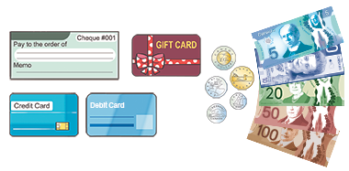 | Describes different payment methods and identifies advantages and disadvantages of each.  “Advantage: money comes out of the bank account instantly  Disadvantage: people tend to spend more money than they would  using cash.” | Compares two different payment methods and determines the more suitable for a given scenario.  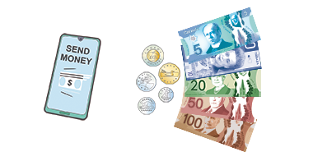  “To send money to a friend in another province, I would use an  e-Transfer as it is much safer than sending cash in the mail.” | Determines the most appropriate payment method and considers the short- and long-term impact.
Observations/Documentation

