Multiplying and Dividing Whole Numbers by Decimal Tenths
Explores and generalizes patterns using place-value relationships.  245 × 1 = 245  245 × 0.1 = 24.5  245 ÷ 0.1 = 2450  “When I multiply by 0.1, the digits shift one place to the right. When I divide by 0.1, the digits shift one place to the left.” | Uses patterns, number relationships, and properties of operations to solve problems.  190 × 0.4 = ?  “I multiplied by 1 tenth first, then multiplied the product by 4.”  190 × 0.1 = 19.0  19.0 × 4 = 76.0  190 × 0.4 = 76.0 | Uses algorithms and checks for reasonableness (e.g., partial products, standard algorithm).  355 × 0.5 = ?  I used partial products to multiply, then estimated to check the reasonableness of my answer.  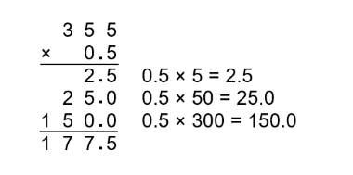  355 is close to 350. 0.5 is the same as one half. One half of 350 is 175.  Since 177.5 is close to 175, my answer is reasonable.” | Flexibly solves multiplication and division problems using a variety of strategies.  428 ÷ 0.4 = ?  “I multiplied both numbers by 10 so I could work with whole numbers, then used an algorithm.”  428 ÷ 0.4 = 4280 ÷ 4
Observations/Documentation

