Multiplying and Dividing Decimals by 1-Digit Numbers
Models multiplication and division situations concretely and pictorially.  1.6 × 3 = ?  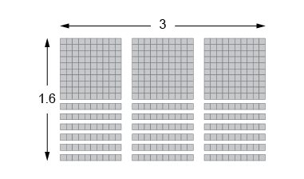  “I used Base Ten Blocks to make an array  with length 3 and width 1.6.  I then counted the blocks to get 4.8”. | Uses models and strategies to solve multiplication and division situations.  4.15 × 5 = ?  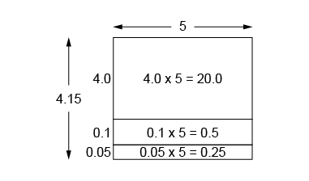  “I used an area model:  4 × 5 = 20;  1 tenth × 5 = 5 tenths, or 0.5;  5 hundredths × 5  = 25 hundredths, or 0.25;  20.0 + 0.5 + 0.25 = 20.75.” | Decomposes numbers to use distributive property and partial products to multiply.  4.15 × 5 = ?  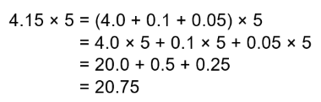
Observations/Documentation

Multiplying and Dividing Decimals by 1-Digit Numbers (cont’d)
Decomposes numbers to use partial quotients  to divide.  21.25 ÷ 5 = ?  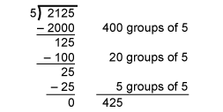  “I used partial quotients to divide as whole numbers, then estimated to place the decimal point. 21.25 is about 20.  20 ÷ 5 = 4  So, I placed the decimal point so 425 is close to 4: 4.25.” | Estimates to determine if answer to multiplication or division problem is reasonable.  38.22 ÷ 3 = 12.74  “I used estimation to check.  38 is close to 39 and 39 ÷ 3 = 13.  Since 12.74 is close to 13,  my answer is reasonable.” | Solves multiplication and division problems flexibly using a variety of strategies.  A bus travelled 446.5 km in 5 h, with no stops.  On average, how far did the bus travel in 1 h?  “I divided as I would whole numbers, then used estimation to place the decimal point.  446.5 is about 450, and 450 ÷ 5 = 90.  I placed the decimal point  so that 893 is close to 90: 89.3.”
Observations/Documentation

