Exploring Fractions, Decimals, Percents, and Integers
Uses counting to determine improper fractions and mixed numbers (based on equivalence).  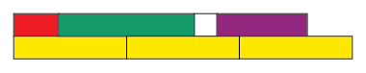  “I counted by fifths. I have  13 one-fifths, which is the same as $\frac{13}{5}$ or 2$\frac{3}{5}$.” | Compares and orders fractions (e.g., using benchmarks, equivalent fractions, number sense).  “To compare $\frac{13}{4}$ and 3$\frac{1}{3}$, I know $\frac{13}{4}$ is the same as 3$\frac{1}{4}$, but 3$\frac{1}{3}$ is closer to 3$\frac{1}{2}$, so I know it is greater.” | Reads and understands decimals as fractions with denominators of 10, 100, or 1000.  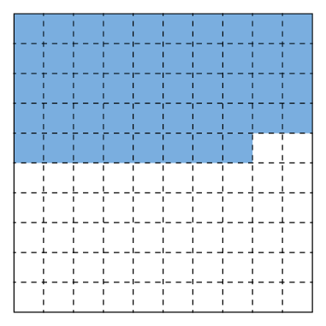  “I have forty-eight hundredths, which is the same as $\frac{48}{100}$.” | Understands the base-ten place-value system and uses it to compare and order decimals.  “Even though 0.575 has more digits than 0.67, 0.575 < 0.67 because five hundred and seventy-five thousandths is less than six hundred and seventy thousandths.”
Observations/Documentation

Exploring Fractions, Decimals, Percents, and Integers (cont’d)
Understands percent as “out of 100” and makes connections with decimals and fractions.  “0.52 is read as 52 hundredths and since percent is ‘out of 100,’ it can also be thought of as  52% of something.” | Understands that a negative number is the opposite of its corresponding positive number.  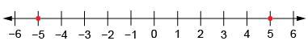  “Negative 5 is the same distance from zero as positive 5.” | Recognizes that negative numbers have both a sign and a direction (size) and their value decreases as the number of digits increases.  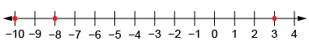  “−8 is less than +3 because it is less than zero; −10 is even less than −8 because it is farther away  from zero.” | Flexibly connects quantities across number systems (fractions, decimals, percents, and integers).  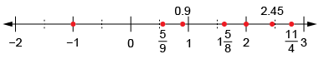  How might you use the different types of numbers in real life?
Observations/Documentation

