Extending Whole Number Understanding
Represents 5-digit numbers on place-value chart (decomposes in one way).  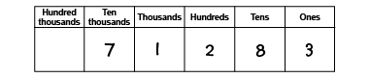  “71 283 has 7 ten-thousands, 1 thousand,  2 hundreds, 8 tens, and 3 ones.” | Represents same number in multiple ways (e.g., words, expanded form, place-value chart).  “71 238; seventy-one thousand two hundred eighty-three; 70 000 + 1000 + 200 + 80 + 3” | Uses relationships among place-value positions to read a number in more than one way.  “7 ten-thousands, 1 thousand, 2 hundreds, 8 ten, and 3 ones can also be 71 thousands, 2 hundreds, and 83 ones.”
Observations/Documentation

Extending Whole Number Understanding (cont’d)
Uses place-value to compare numbers.  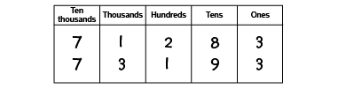  “Both numbers have 3 ten-thousands. Since 3 thousands is more than 1 thousand, 73 193 is greater than 71 283.”  73 193 > 71 283 | Uses place value to compare and order numbers.  65 218, 56 812, 65 018, 65 208  “I compared the digits in each place-value position. From least to greatest:  56 812, 65 018, 65 208, 65 218.” | Extends whole number understanding up to and beyond 1 000 000.  “To represent 1 639 587, I have to add 2 columns to the place value chart: one for hundred-thousands and one for millions.”
Observations/Documentation

