Using Nets to Determine Surface Area of Prisms and Pyramids
Uses nets to calculate surface area by adding the partial areas.  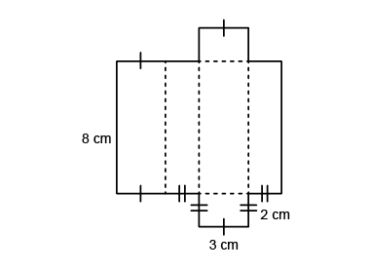  “I added the partial areas:  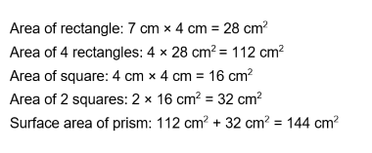 | Uses net to show relationship between areas of faces and surface area of prism/pyramid.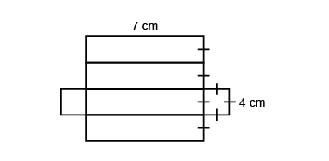  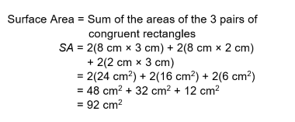 | Determines surface area by visualizing net and adding the areas of its faces.  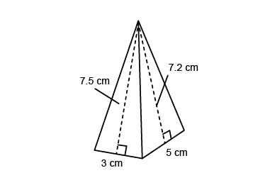  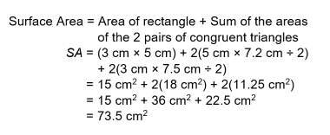 | Flexibly solves surface area problems by adding the areas  of 2-D faces.  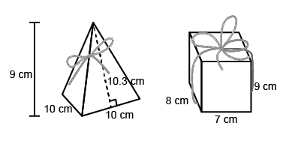  Which box would need less wrapping paper?  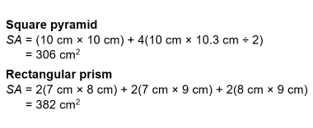
Observations/Documentation

