Investigating Mass and Capacity
Identifies which metric unit should be used to measure the mass and/or capacity of an object.  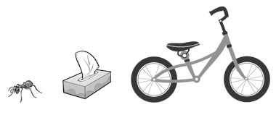  “I would use milligrams for the ant, grams for the tissue box, and kilograms for the bicycle.” | Uses benchmarks to estimate mass or capacity using metric units, then measures to check.  “A carton of milk has a capacity of about 1 L.  I estimated that the paint can holds about 4 L.  I measured to check: 3.8 L.” | Chooses an appropriate metric unit to estimate and measure mass and/or capacity of object and explains reasoning.  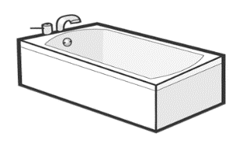  “I would use litres to measure the capacity of the bathtub because I know it has a capacity much larger than a 1-L carton of milk. I think it would take about 180 L to fill the bathtub.”
Observations/Documentation

Investigating Mass and Capacity (cont’d)
Explains the relationship between metric units of mass and/or capacity and converts between units.  Rhianna drinks 1500 mL of milk at school in one week. How many litres does she drink?  “I know 1000 mL = 1 L, so 500 mL = 0.5 L;  1 L + 0.5 L = 1.5 L.” | Compares and orders items by mass and/or capacity when measures are given in different units.  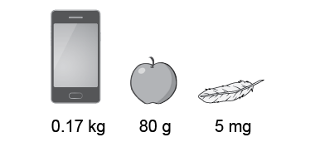  “I converted the mass of each object to grams: 0.17 × 1000 = 170 and 5 ÷ 1000 = 0.005.  The order from least to greatest mass is feather (0.005 g), apple (80 g), and cell phone (170 g).” | Flexibly solves problems in various contexts where measures of mass and/or capacity are given in different units.  One peach has a mass of 150 g. How much will it cost for 8 peaches if they sell for $5 per kg?  “I found the mass of 8 peaches in kilograms: 8 × 150 g = 1200 g, or 1.2 kg; I kg costs $5; 0.2 kg is one-fifth of 1 kg and one-fifth of $5 is $1;  $5 + $1 = $6.”
Observations/Documentation

