Applying and Visualizing Transformations on a Grid
Identifies and describes transformations on a grid.  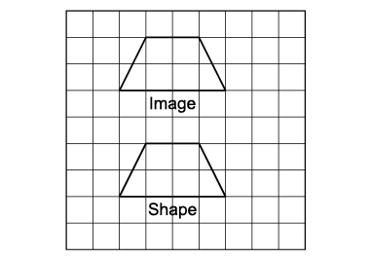  “This shows a translation because the shape and the image face the same way.” | Describes and performs single transformations on a grid.  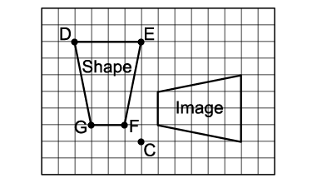  “The shape was rotated 90° about the point of rotation C to get  the Image.” | Describes and performs combinations of transformations.  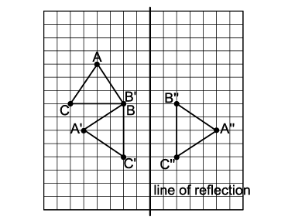  “The triangle is rotated 270° clockwise about vertex B, then reflected in the vertical line.” | Visualizes, describes, and flexibly performs a combination of transformations.  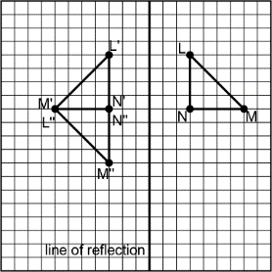  “I visualize reflecting triangle LMN in the vertical line of reflection, then rotating the image 90° counterclockwise about N’ to get triangle L”M”N”.”
Observations/Documentation

Applying and Visualizing Rotations on a Grid (cont’d)
Identifies rotation that takes a shape to its image on a grid (point of rotation on shape).  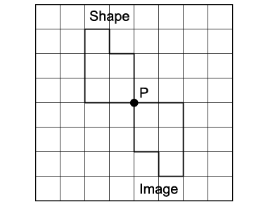  “I know the shape was rotated 180° clockwise about vertex P.” | Identifies rotation that takes a shape to its image on a grid (point of rotation off shape).  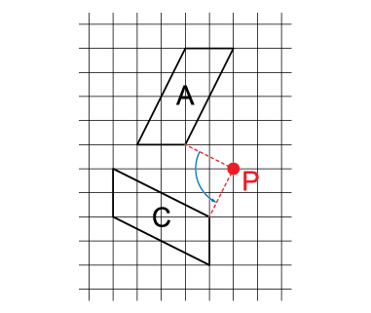  “I know the shape was rotated 90° counterclockwise about point P.” | Performs and describes various rotations with angles of rotation  to 360°.  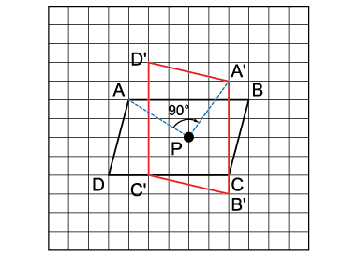  “I used the point of rotation to rotate the shape 270° counterclockwise.  If I rotated the shape 90° clockwise,  I would get the same final image.  I know the image is correct because each vertex and its image are the same distance from point P and the angle between the lines joining matching vertices to the point of rotation is 90°. | Visualizes, predicts, and describes where the image of a shape will be after a rotation.  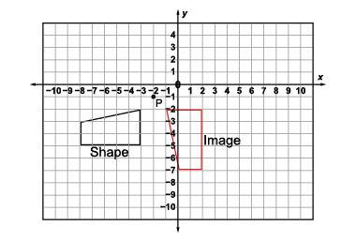  “I can picture rotating the shape 90° counterclockwise about the  point of rotation, P.”
Observations/Documentation

