Applying and Visualizing Rotations on a Grid
Identifies rotation that takes a shape to its image on a grid (point of rotation on shape).  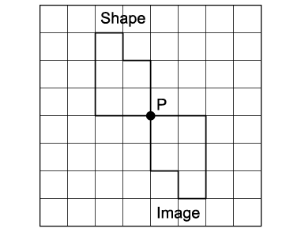  “I know the shape was rotated 180° clockwise about vertex P.” | Identifies rotation that takes a shape to its image on a grid (point of rotation off shape).  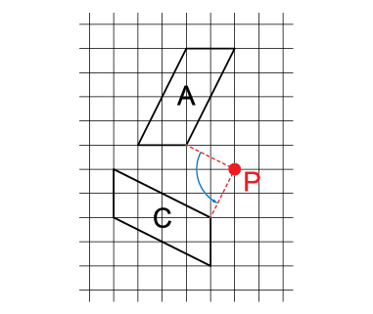  “I know the shape was rotated 90° counterclockwise about point P.” | Performs and describes various rotations with angles of rotation  to 360°.  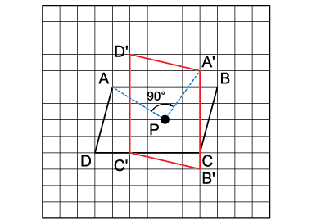  “I used the point of rotation to rotate the shape 270° counterclockwise.  If I rotated the shape 90° clockwise,  I would get the same final image.  I know the image is correct because each vertex and its image are the same distance from point P and the angle between the lines joining matching vertices to the point of rotation is 90°. | Visualizes, predicts, and describes where the image of a shape will be after a rotation.  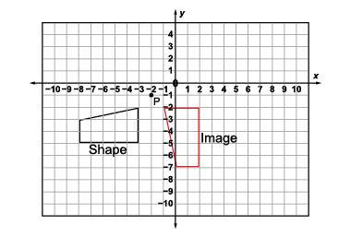  “I can picture rotating the shape 90° counterclockwise about the  point of rotation, P.”
Observations/Documentation

