Applying and Visualizing Transformations on a Grid
Identifies and describes transformations on a grid.  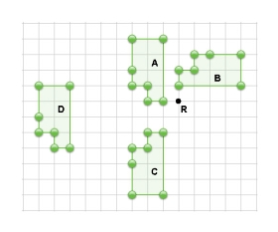  “Shape A to Shape D is a translation. Shape A is reflected in the horizontal line halfway between Shapes A and C to get Shape C. Shape A is rotated 90° clockwise about point R to get Shape B.” | Describes and performs single transformations on a grid.  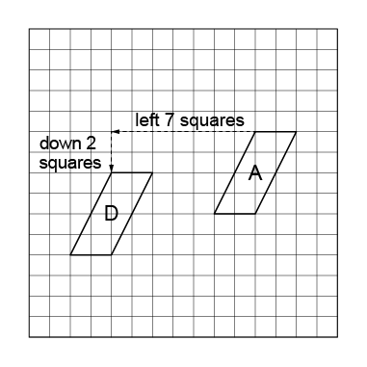  “I translated Shape A left 7 squares and down 2 squares to Image D.” | Describes and performs combinations of transformations.  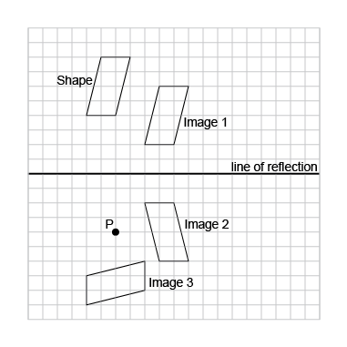  “I used a combination of transformations. I translated the Shape right 4 squares, down 2 squares to Image 1; I reflected Image 1 in the line of reflection shown to get Image 2; I rotated Image 2 90° clockwise about point P to get Image 3.” | Visualizes, describes, and flexibly performs combinations of transformations.  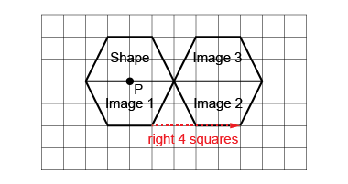  “I visualized the transformations and predicted where the images would be. I performed the transformations to check. I rotated the shape 180° about point P to get Image 1; then translated Image 1 right 4 squares to get Image 2; then reflected Image 2 in the common side to get Image 3.  My predictions were correct.”
Observations/Documentation

